# *Tableau_DataCamp*

## *Referance, Trends & Forecast*

* Referance: analytics -> reference line;
* Trends: analytics -> trend line;
* Forecast: analytics -> forecast;
* Tooltip -> use to add more information about metrics for specific visualization.

## *Data manipulation*

### Measures and Dimensions

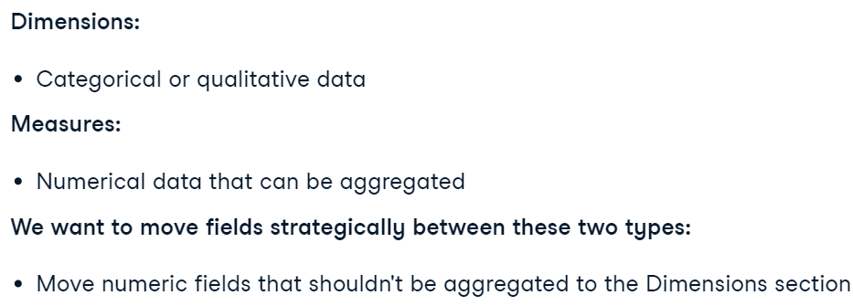

### Discrete or Continuous time analisys

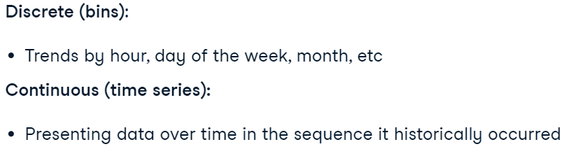

Example:

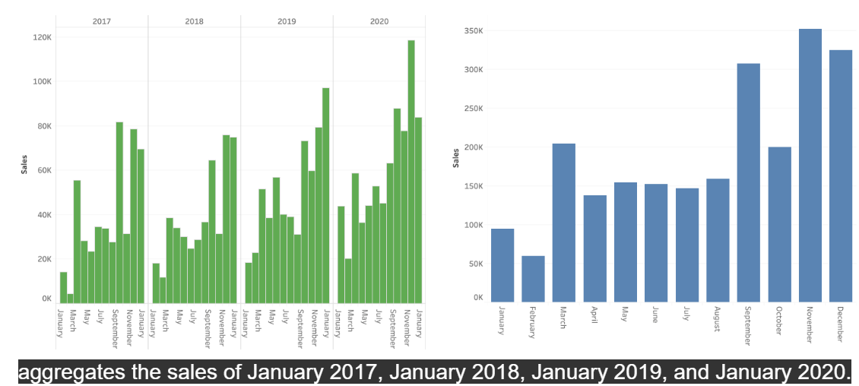

### Techniques

* Digit manipulation and adding suffixes: 2tap -> default properties -> number format
* Highlighting the row: Analysis -> Highlighters
* DATEDIFF(‘year/quarter/month/day/minute’, less_column, bigger_column) – calculates the difference between columns
* DATEPART(‘weekday’, column) – extracts the number of the day, month, etc.
* IF/ELSE/END

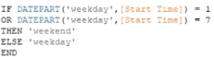

* Discrete / continuous measures

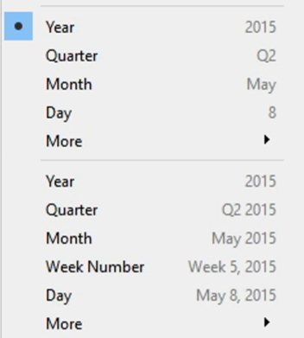

* Different type of calculations: agg_field -> quick table calculation -> …
* agg_field -> default properties -> number format -> …
* Calculation all of the possible values: analysis -> totals -> …
* Changing the type of computing (from rows to columns and vice versa): agg_field -> compute using -> …
* Label -> alleviates the process of giving additional information to our vizualisation.
* Setting approppriate **filter** (to have solid ties):

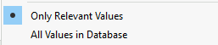

* Flter for DashBoard:

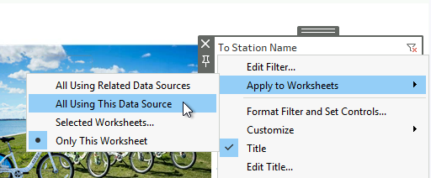

* Adding filters to the DashBoard from sheets:

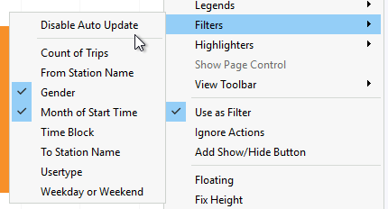

* **Creating bins for hists** -> column -> create -> bins -> …
* Manipulation Maps -> map -> choose your settings -> ...
* We can use “**Pages shelf**” to set our data in motion using different intervals, by -> column -> put on “pages”.
* Label – can manipulate visualization marks and numbers on it.

* Ranking –> filter (agg) -> quick table calculation -> rank
* Ranking: settings -> rank
* Changing type of ranking -> click on the ranking filter -> ‘Edit table calculation’ -> …
* Adding additional information from another worksheet: marks -> tooltip -> insert -> sheets.

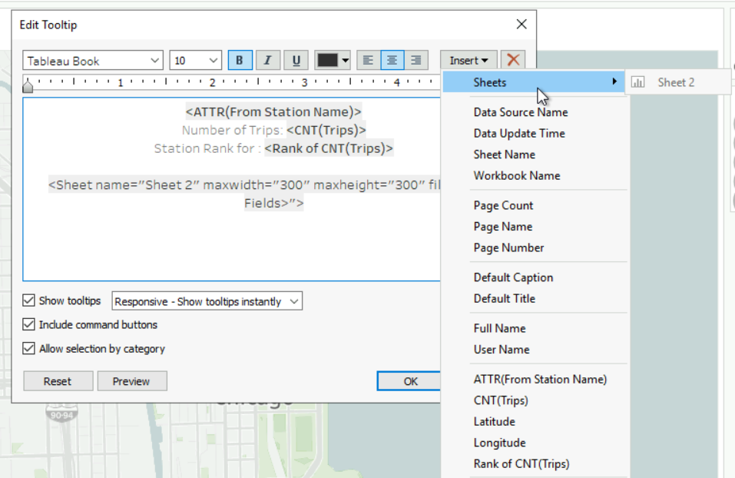

* **Add to the visualization (pieChart) numeric dependency -**> marks -> drag “agg field” to the (Angel).
* Different types of sorting:

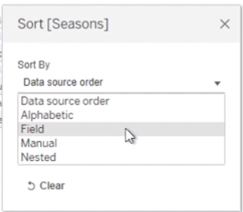

* Applying **filters** to several worksheets:

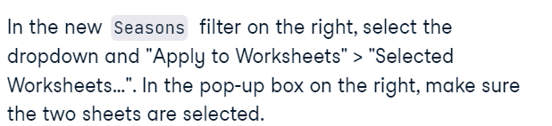

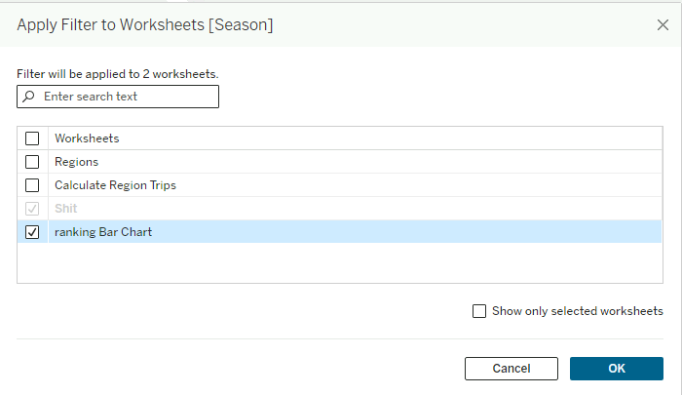

### Groups, Sets, and Parameters

#### Groups

* When to use Groups:

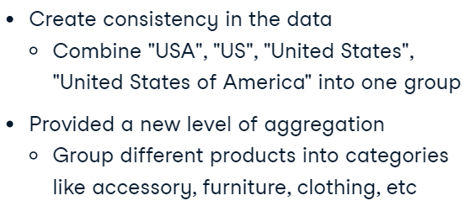

* Groupping -> highlight necessary things -> group
* Change groups:

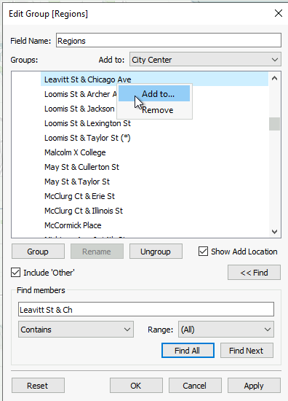

* Ranking (by “Season”): in Tooltip:

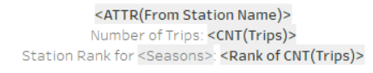

#### Parameters

* What is *parameter*:

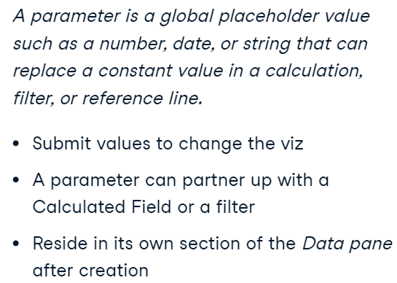

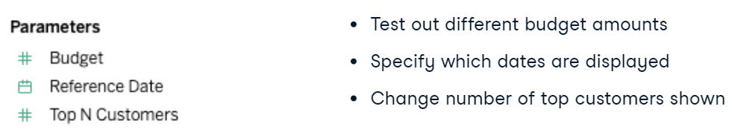

* Creating a parameter: find the “parameter” under the “calculated” field -> configure settings

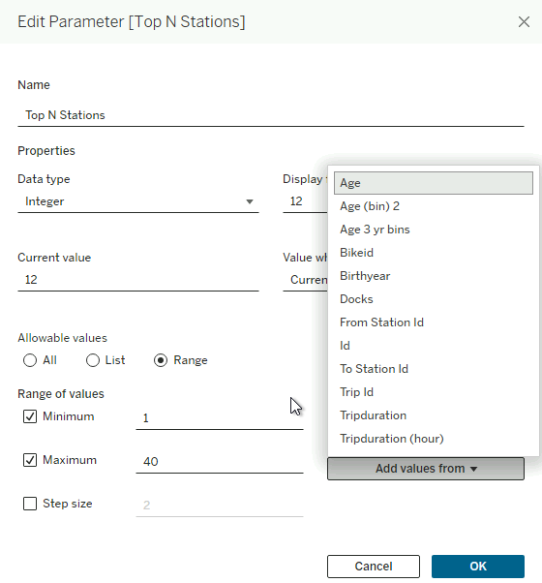

* Applying parameter in filter:

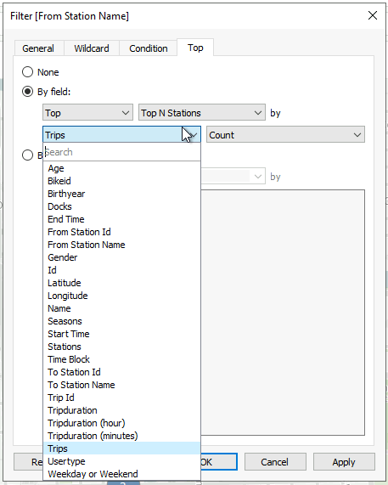

* Applying parameter in calculation:

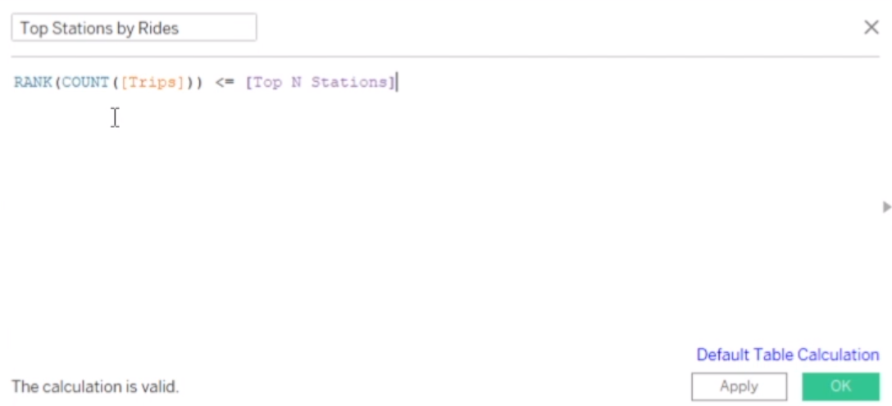

#### Set

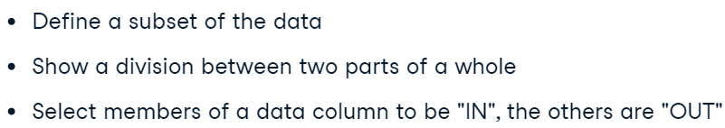

* When use:

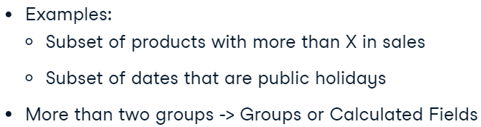

* **Sets**: choose rows or columns you need and click “Set”.

In order to see better difference on viz – you have to drag set on the “colour” mark.

## Dash Boards

### Main questions:

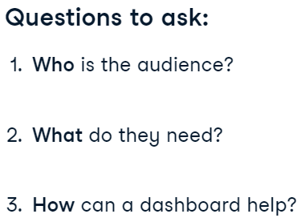

* Changing the view of each viz: settings -> fit -> entire view.
* Take specific area on viz: right bottom -> annotate -> area.

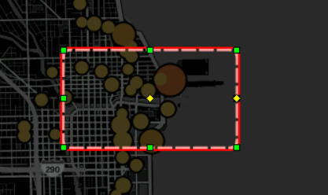

* Creating dynamic floating worksheet for the dashboard: Creating Dashboards with Tableau -> chapter #1 -> using a dynamic title.

**Creating dynamic annotate** (on the right corner): in created sheet you have to edit the Text and locate in the way you want. And then add it to the dashboard. Don’t forfet to fit it width.

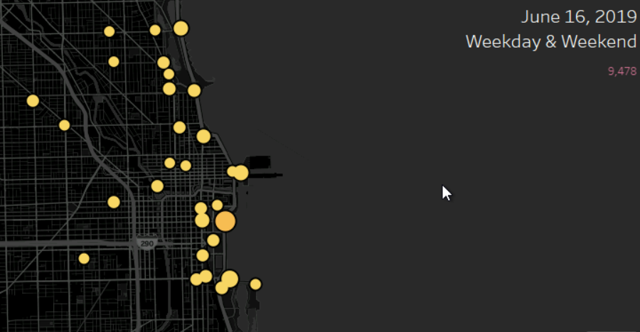

### Objects:

* Add grand title to dashboard: take ‘horizontal’ or “vertical” field on the left corner.

* Delete filter from the dashboard: go to the sheet, where that filter is established.
* Additional filters to the dashboard: worksheet -> more options -> filters / legend.
* Add mark to the viz: double click point -> annotate -> mark -> formatting.
* Adjust DB for specific type of device: dashboard -> “device preview” -> choose device.
* Creating a navigation: dashboard -> objects -> navigation -> choose essential db.

## Tableau files types

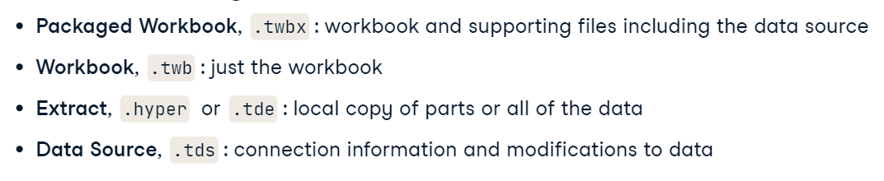

**Extracts**

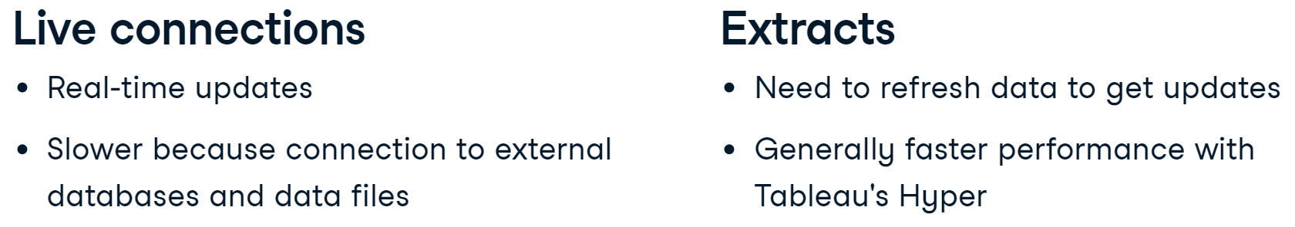

## Conducting elementary operations with Tableau

* Creating hierarchy - Just flip over one fiel over another one.

Example: 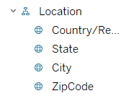

## Filters

* **Types of filters:**

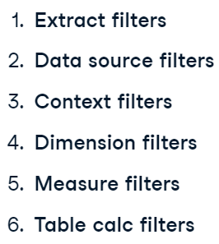

* Data source filters: data source -> data-> edit data source filters.
* *Context filter* (helps to use previous filters and apply to any situation)–> filters –> add to context.

## Joining

1. Left, right, inner, outer;
2. Connecting to table on common column;
3. Connect tables under the main table (as concatenating).

## Data vizualizaton

### Techniques

* Rid of the lines on the viz:

Take format on the chart ­­–> format lines ­–> grid lines ­> none

* Constant line (**summarize**) – is a line, which demonstartes (median, avg and other agg func) on the the viz.

Example in (Data_Viz_1)

* Accessing to **Actions (manipulates dashboard)**: Dashboard ­–> Actions –> …

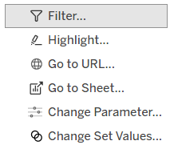

Example of “Go to URL”:

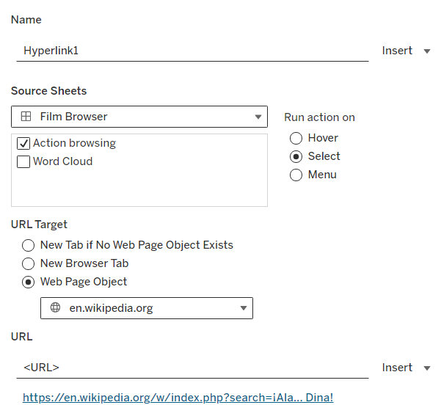

Example of “Highlight”:

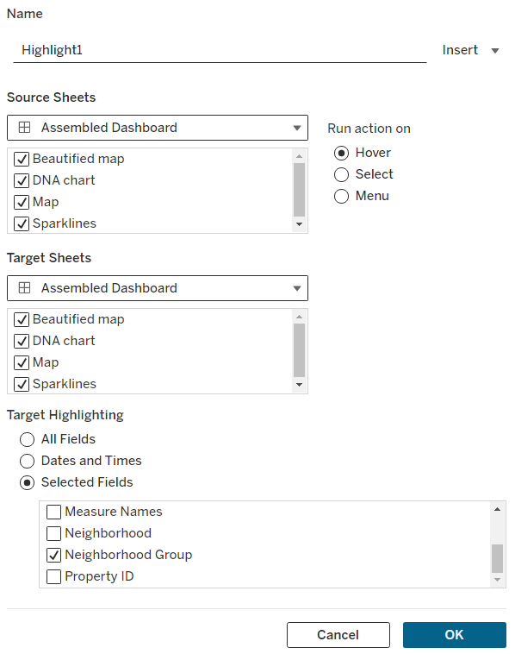

Example of “Filter”:

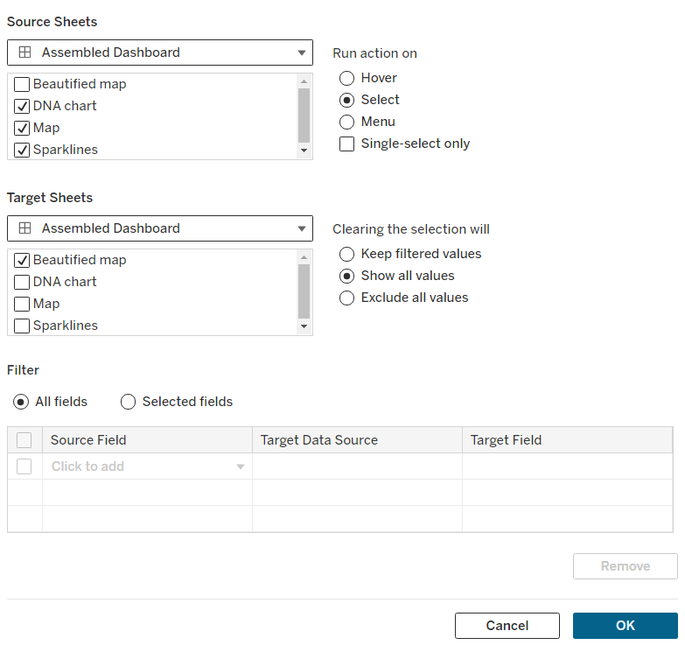

Example in (Data_Viz_2_2)

& (Data_Viz_4_2)

* Hiding null values: Analysis –> Special Values –> Hide

### Gradient

* Create step-gradient:

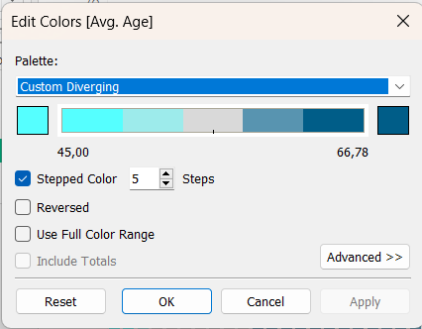

/\

* + Manipulating color displayed:

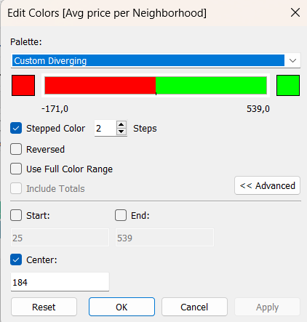

* Show null controls (filter –> customize) – manupulates, which values to demonstrate.

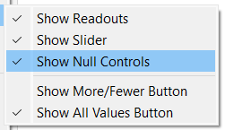

### Vizualizations

#### Maps

* Changing view of a map: map –> backgroud layers –> change style.

#### Waterfall chart

1. Take the “Running totals” for your variable;
2. Select the Grant Bar viz in Marks;
3. Drop the name of the measure to the size in Marks;
4. Correct the measure to negative;
5. Drop the measure to the color mark.

Example in (Data_Viz_1_2_waterfall)

#### Word cloud

1. Take any viz;
2. In Marks take “Text chart”.

Result:

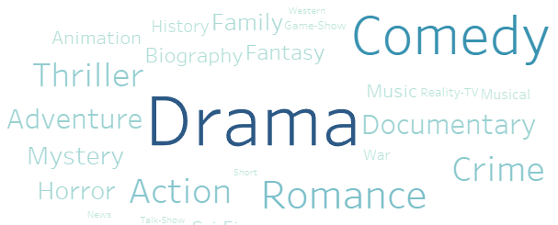

Example in (Data_Viz_2_2)

#### Waffle chart

* When use:

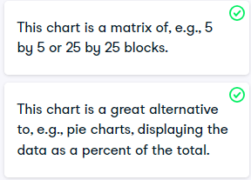

Example in (Data_Viz_4_1)

#### DNA chart

* When use:

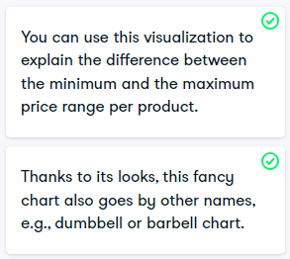

Example in (Data_Viz_4_1)

How to do: https://campus.datacamp.com/courses/data-visualization-in-tableau/information-is-beautiful-expanding-your-charting-toolbox?ex=3

#### Sparklines

* When use:

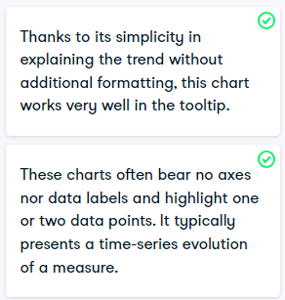

Example in (Data_Viz_4_1)

### HOW TO ATTRACT ATTENTION

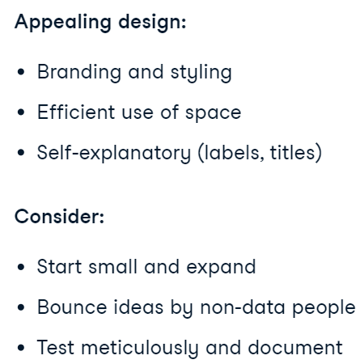

### Question before viz:

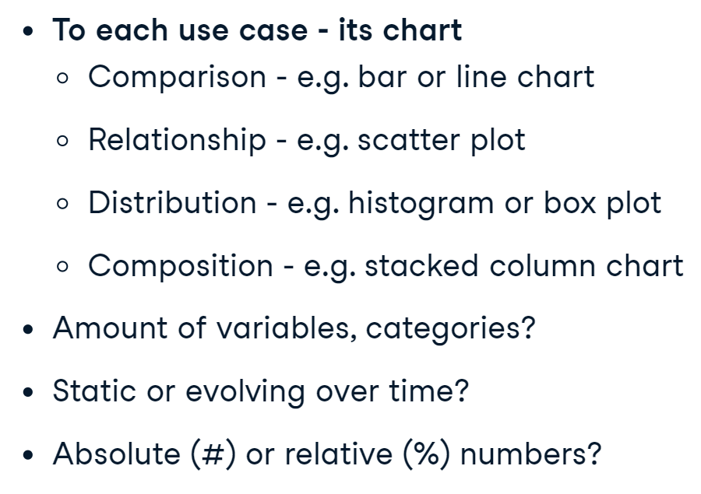

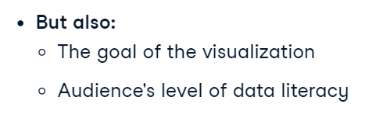

### Using of color

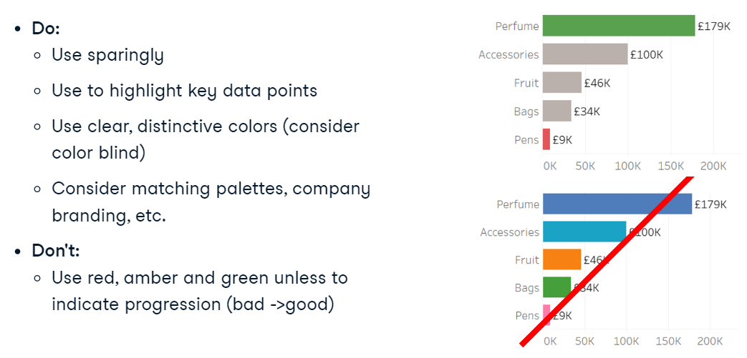

### Size and shape

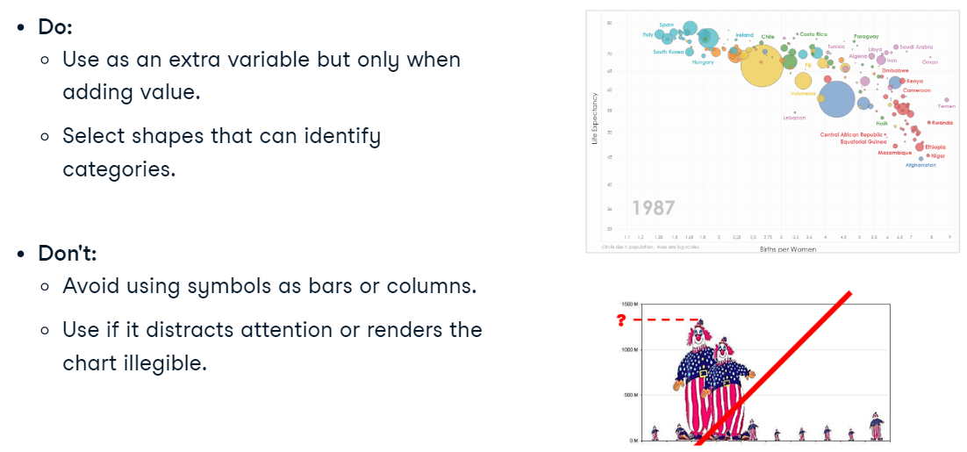

### Design, formating, interactivity

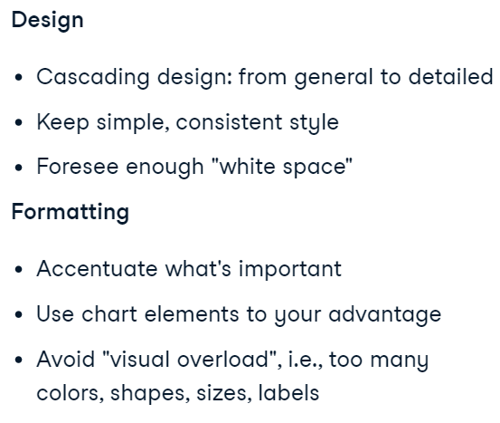

Example in (Data_Viz_4_2)

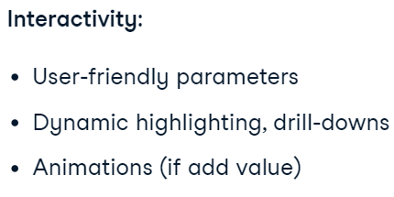

### User-friendly

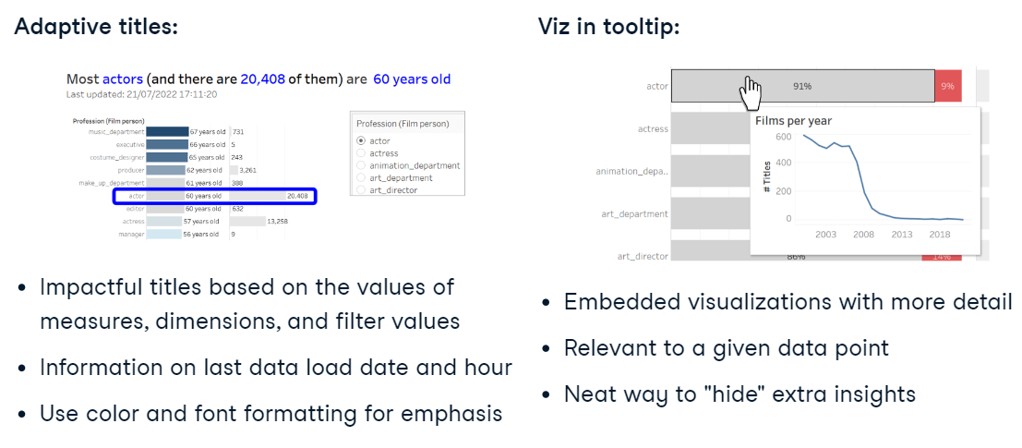

### Best Dashboard

* Explonation:

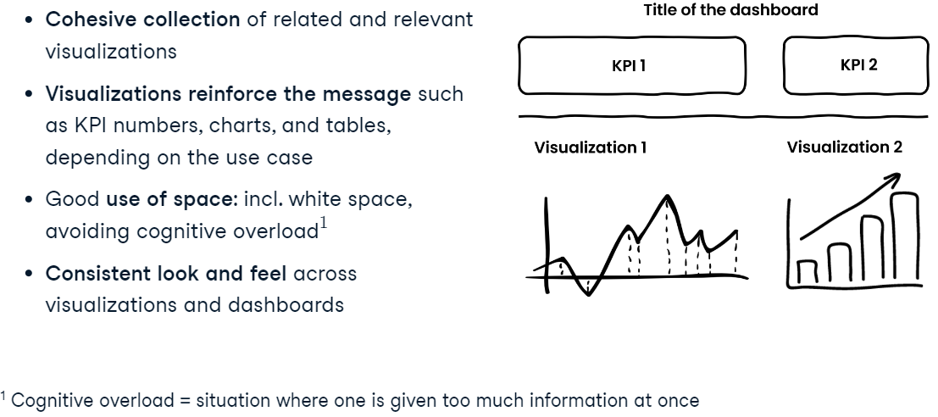

* Interactivity:

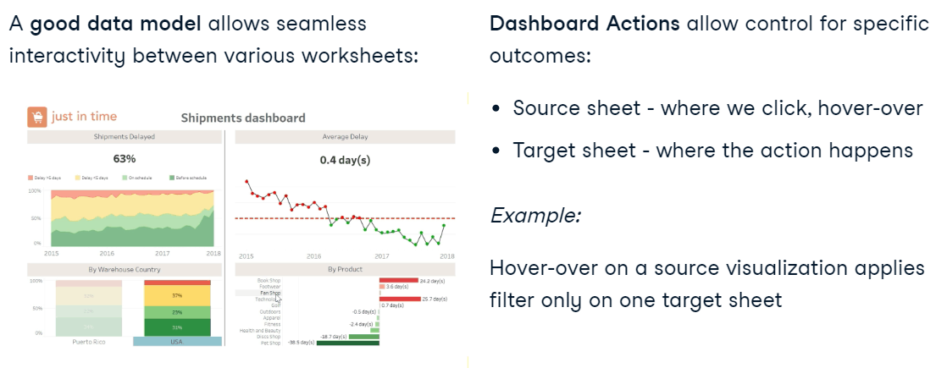

* Steps:

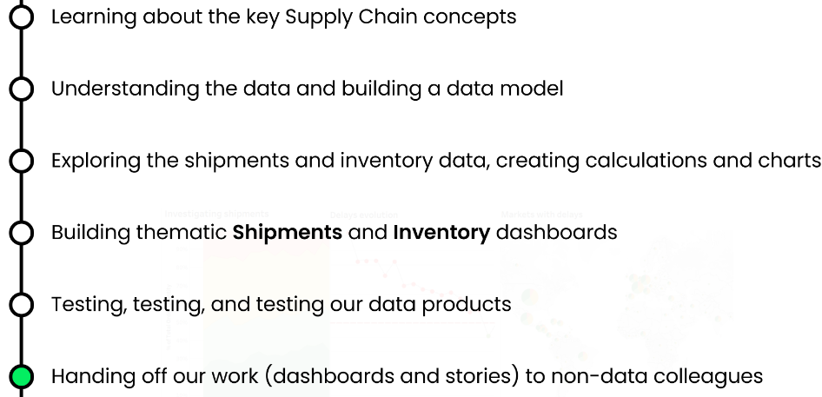

## Calculations in Tableau

* Why I should use it:

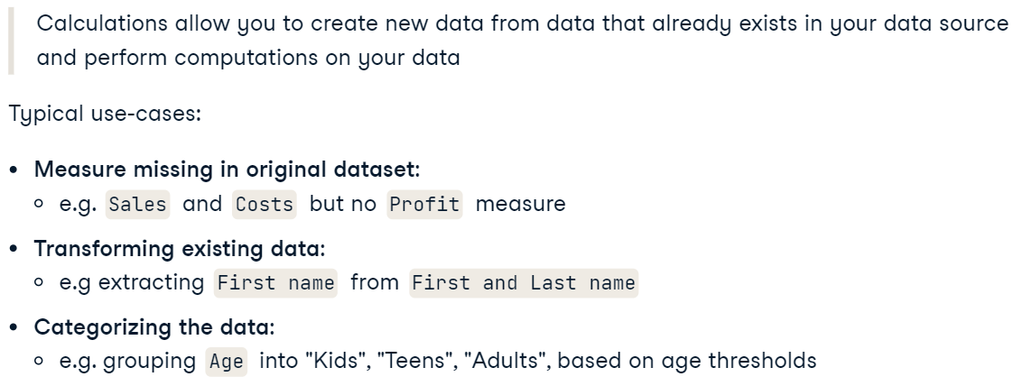

### Techniques

* Max / min value on the viz:

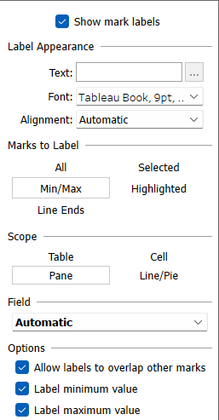

* Spliting string:

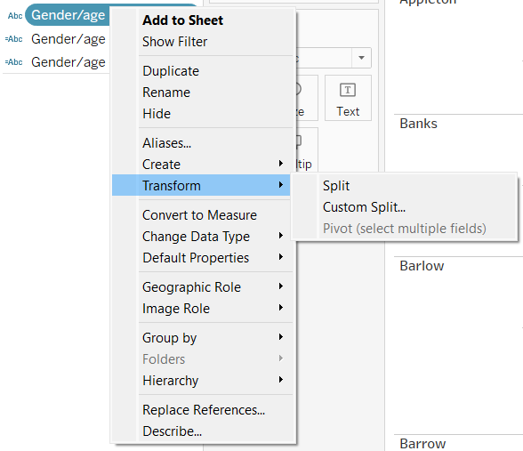

* Changing the aliases for data to display:

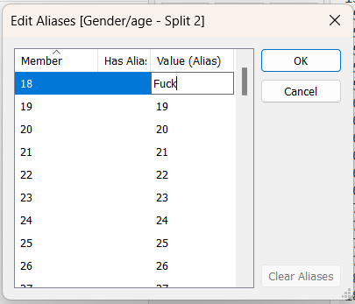

* How to extract exact date:

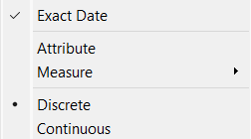

* Adding reference linnes:



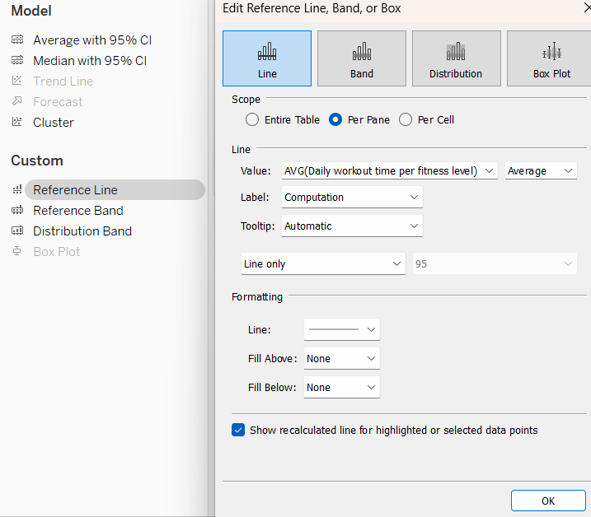

* Pane (down) – calculate each entity separatly (quarter, year)
* Adding table calculation:

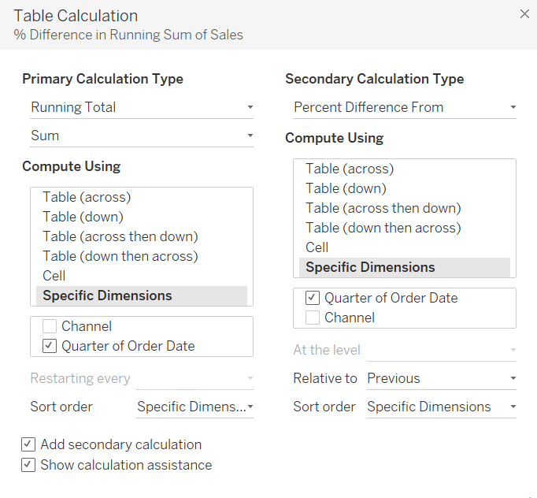

* Reverse axis:

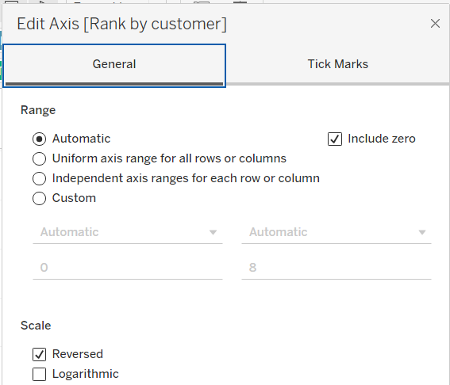

* Adding parameter to reference line:

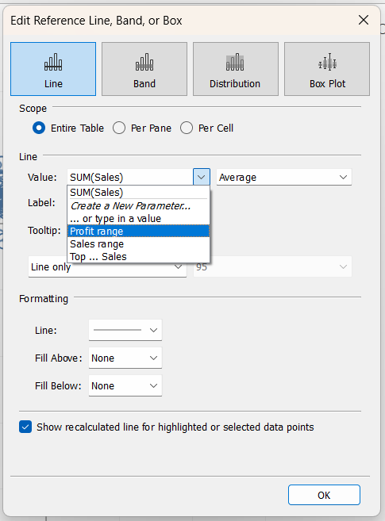

* Slider parametr – have to choose min, max, avg in table (range in parametr):

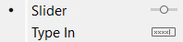

* Changing the locate:

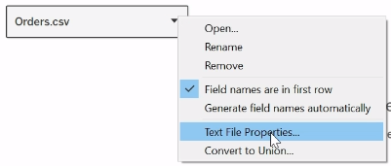

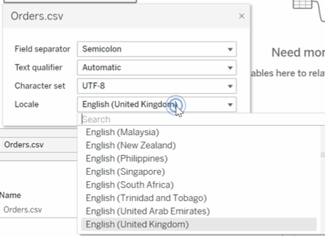

/\

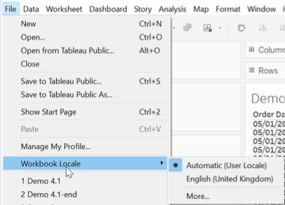

* Moving Average & Compound Growth Rate:

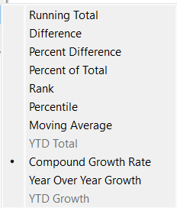

### Types of calculations in Tableau

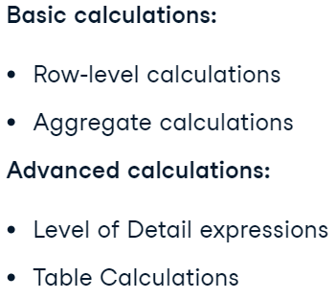

* Row-level:

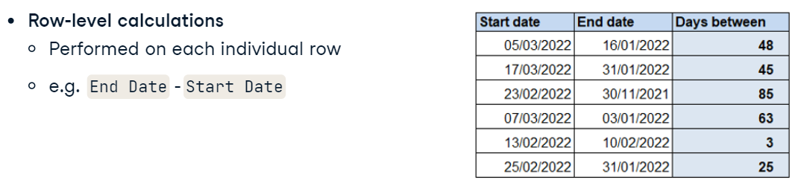

Example: TC_1_1

* Aggregate:

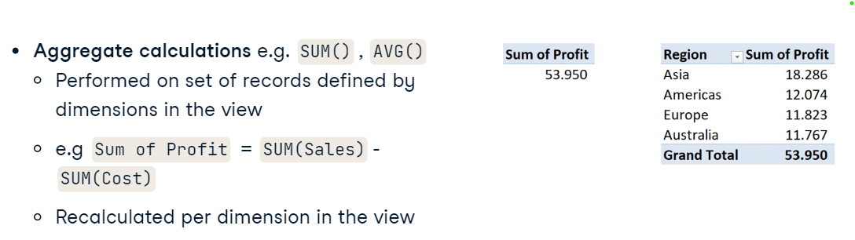

Example: TC_1_1

### Most common logical errors

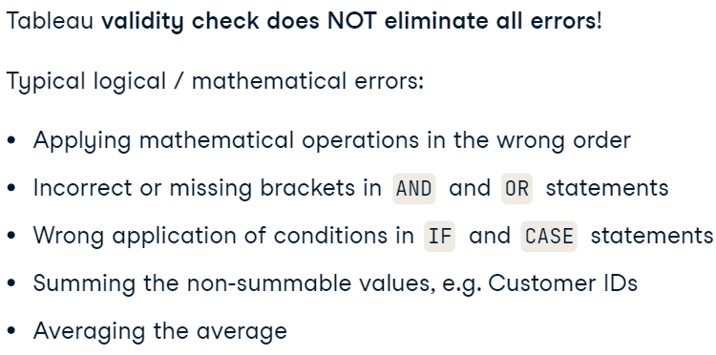

### Data types

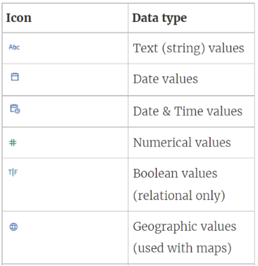

#### String functions

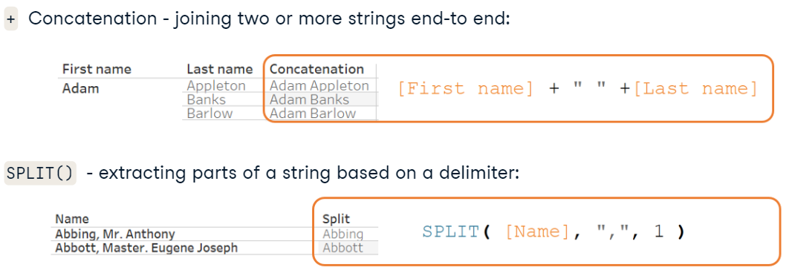

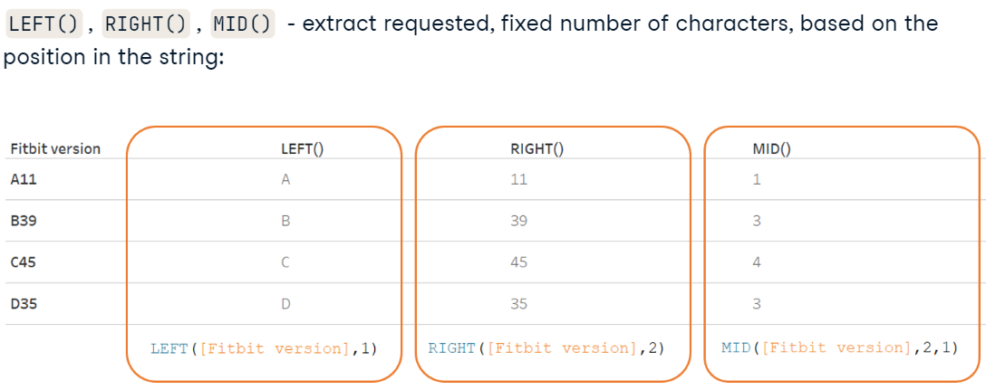

#### Logical functions

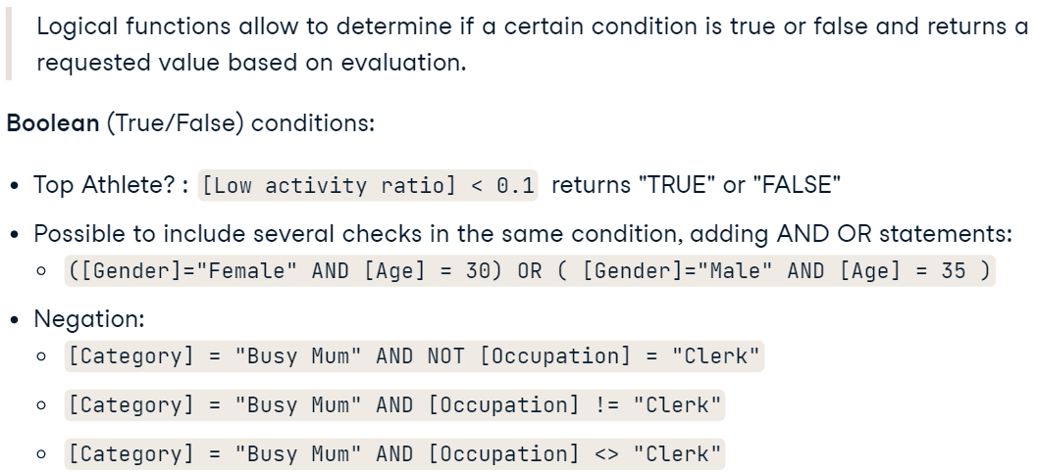

* IF, ELSEIF, ELSE, END:

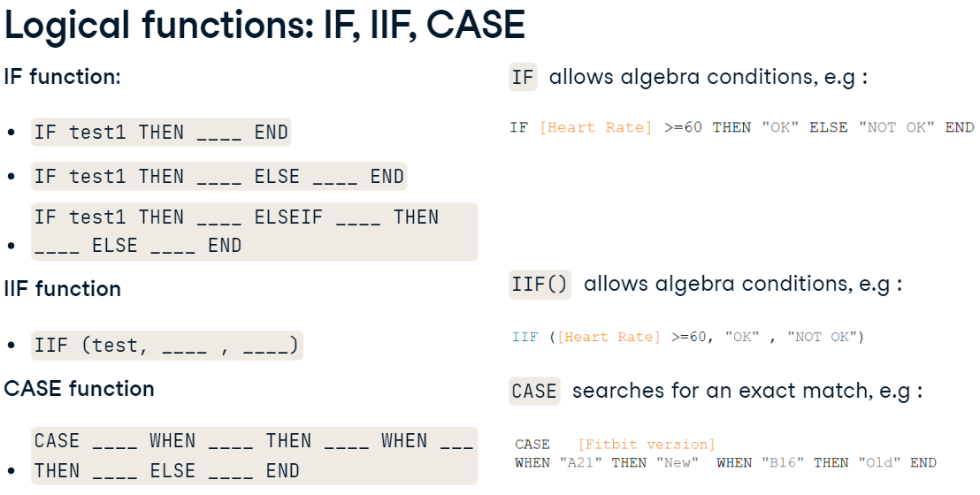

* ISNULL, ISDATE, IFNULL, ZN:

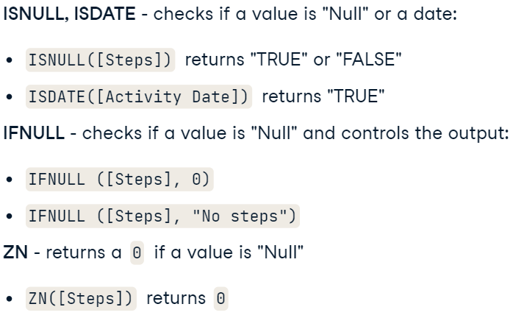

### LOD Expressions and FIXED

* Granularity of the data



#### LOD Expressions in Tableau

* What it is?



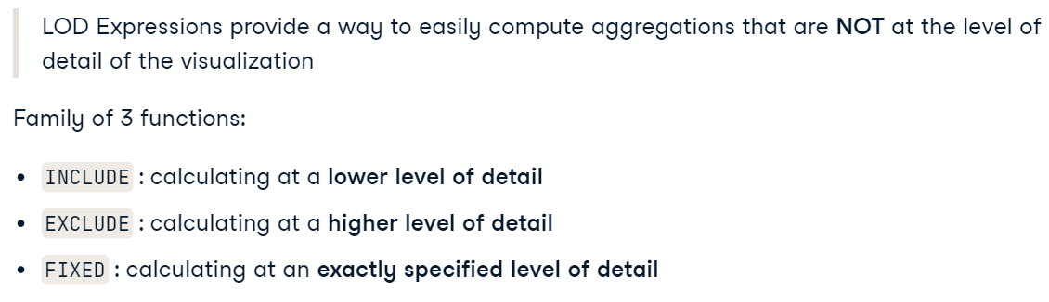

#### FIXED LOD Expressions

* What is it?

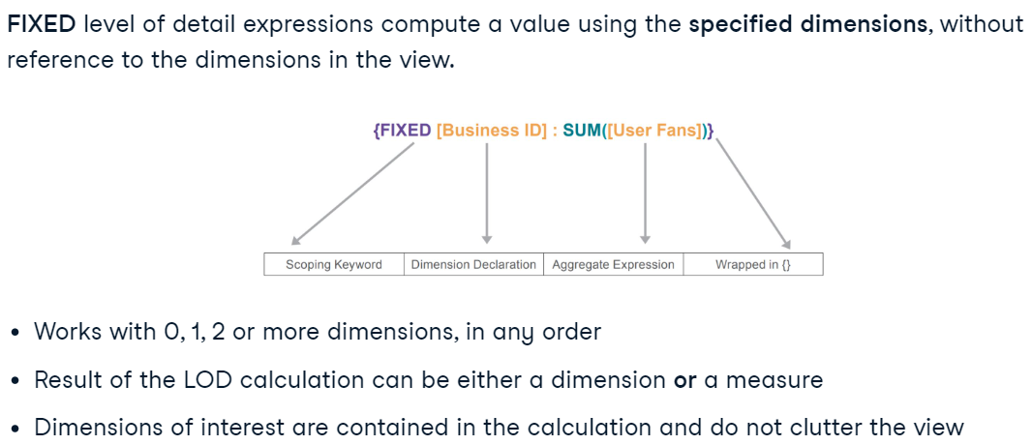

* When use?

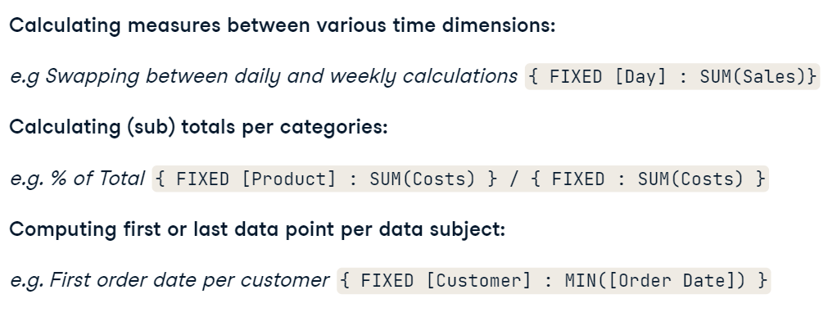

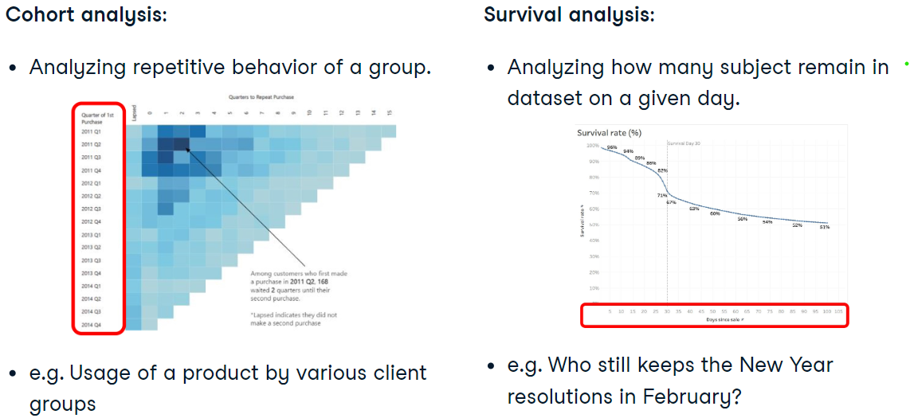

#### INCLUDE LOD Expression

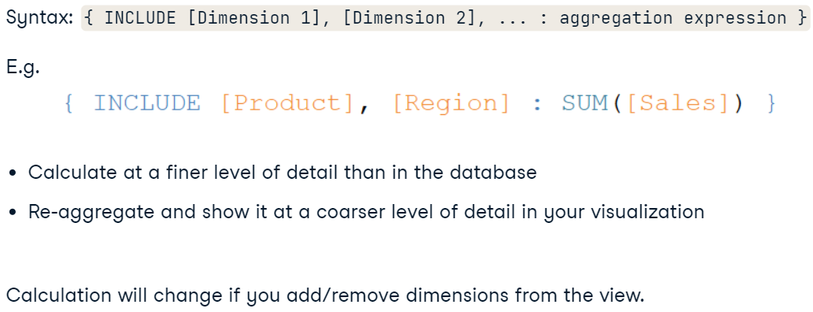

* Example:

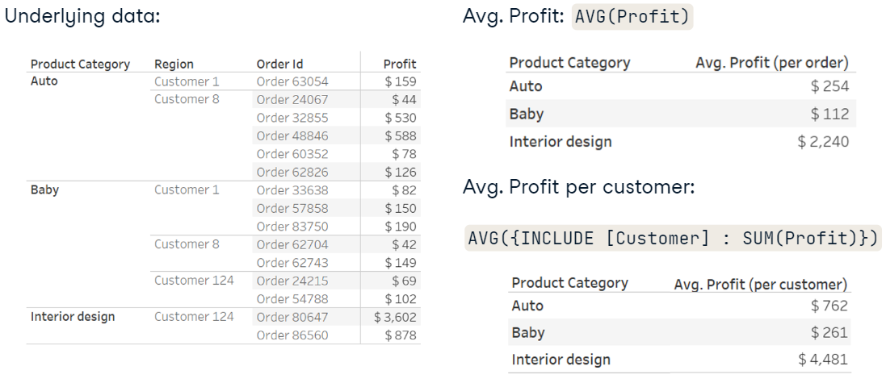

#### EXCLUDE LOD Expression

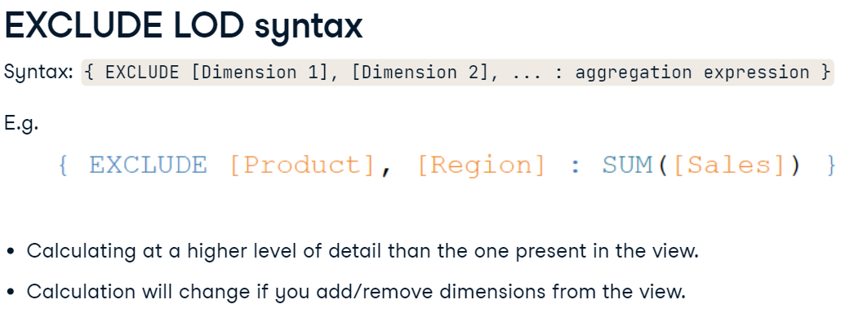

* Example:

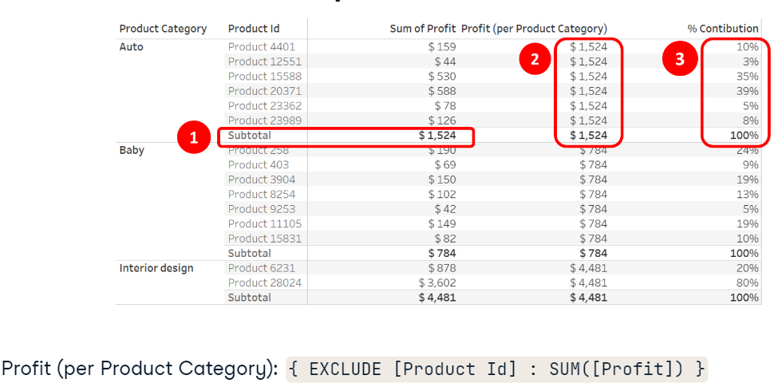

#### When executes

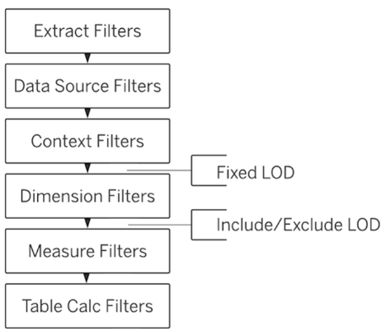

### Table Calculations

* What is it?



* Quick table calculation:

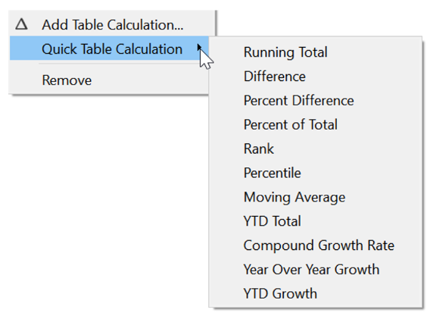

* Partitioning:

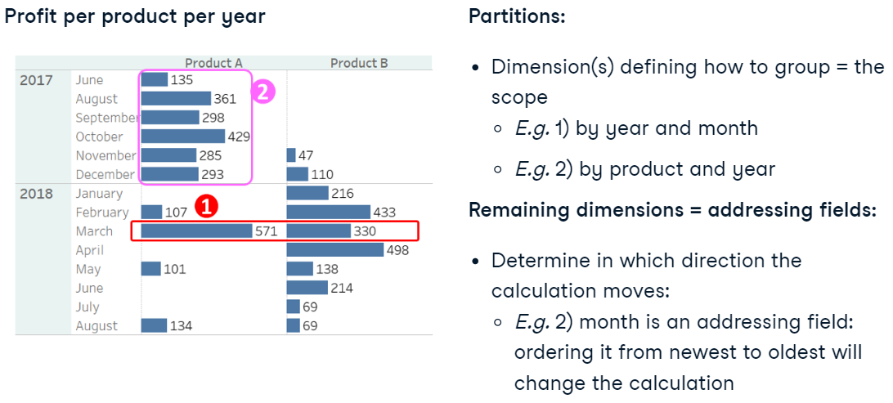

* Running func and window func:

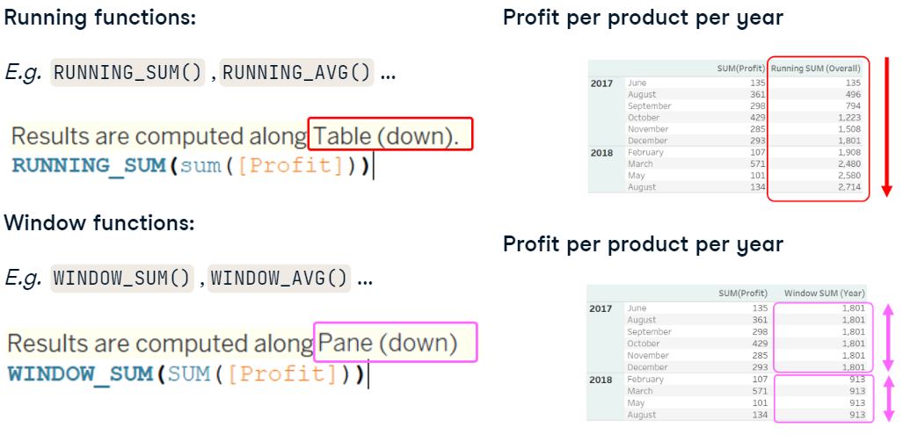

### Parameters

* What is it?

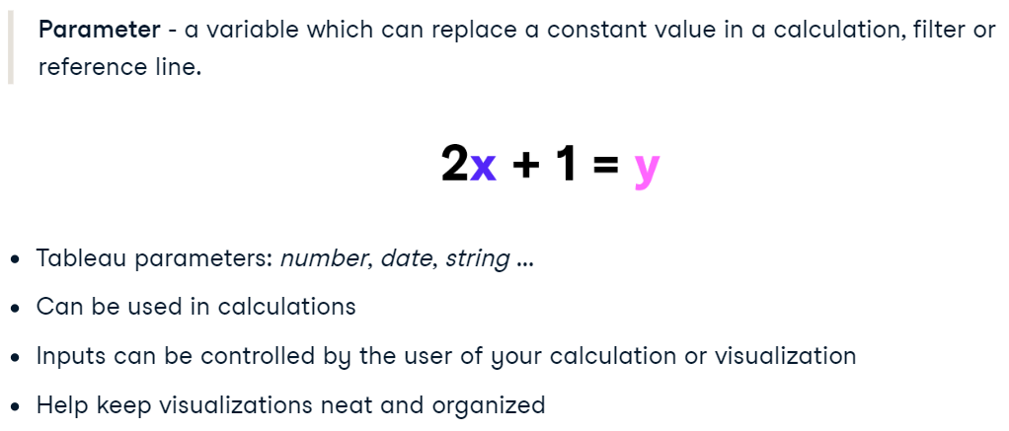

* Types (**top n**):

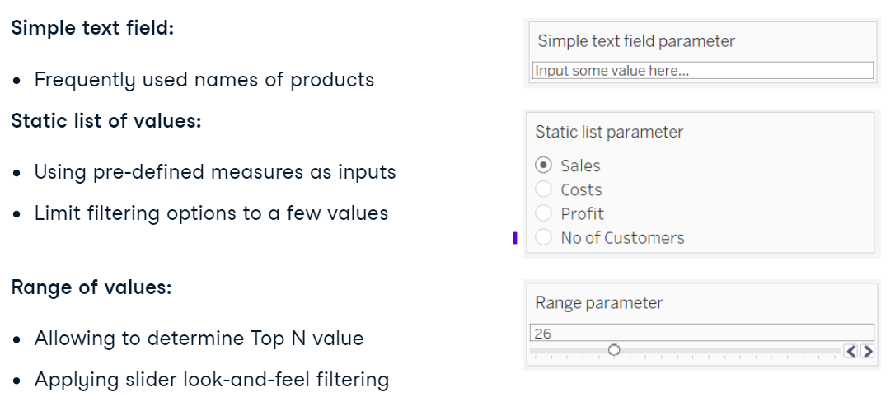

* When use (**switch measure**):

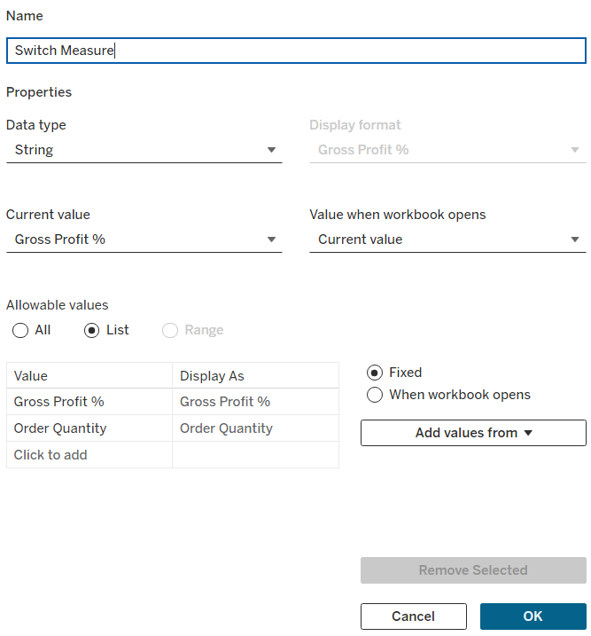

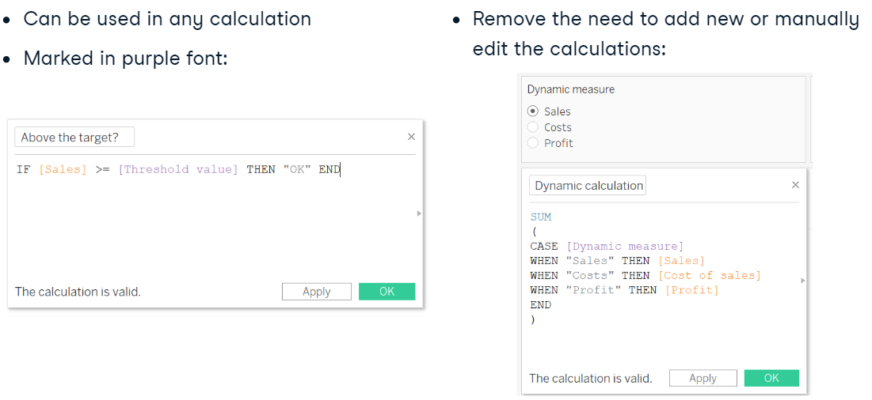

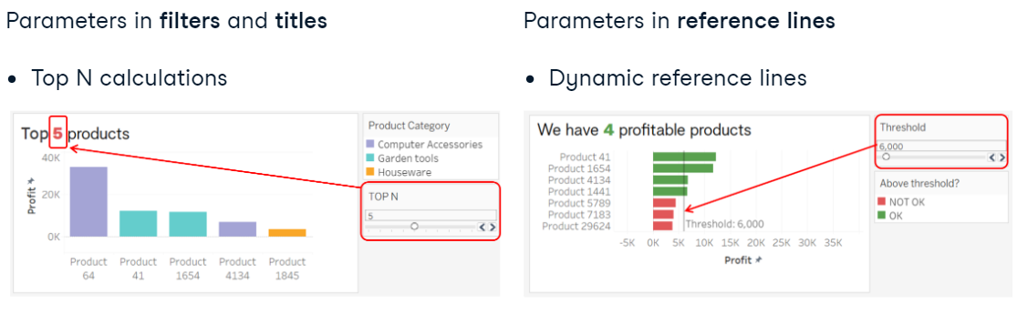

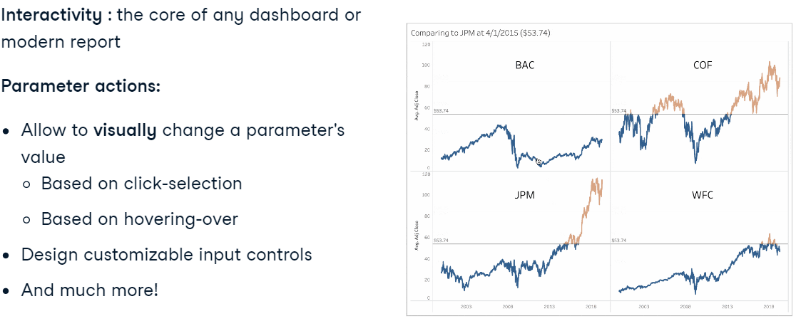

### Date and time functions

* Deriving data from other columns:

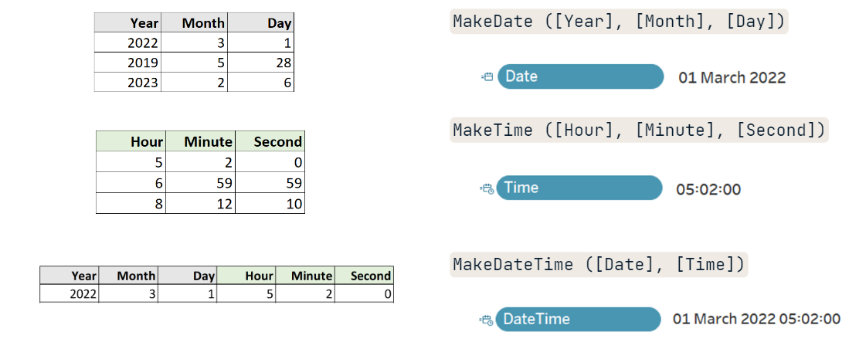

* Parsing date:

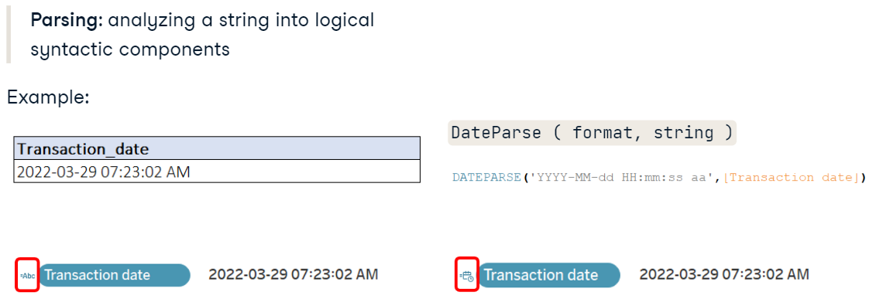

* Extract date parts:

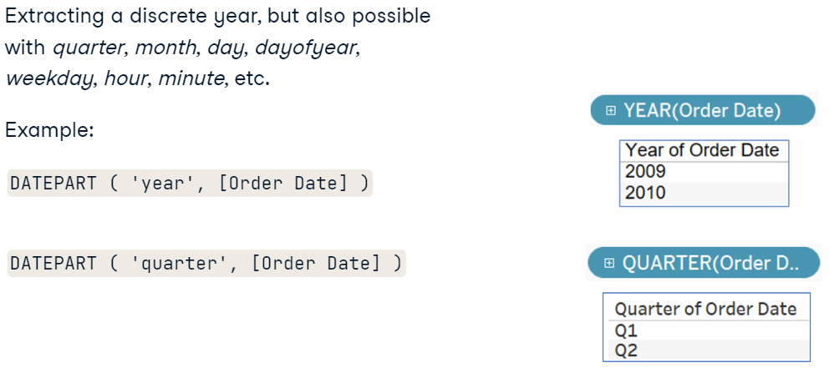

* Truncate:

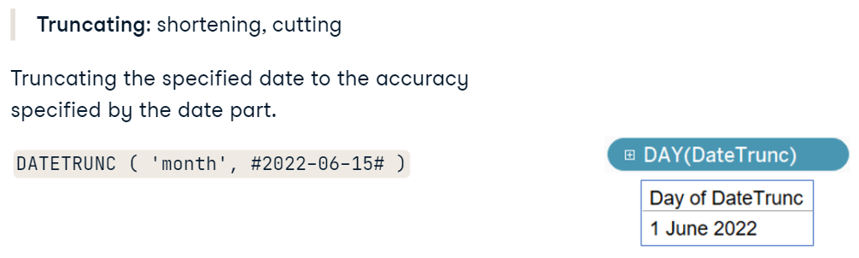

* Calculating with dates:

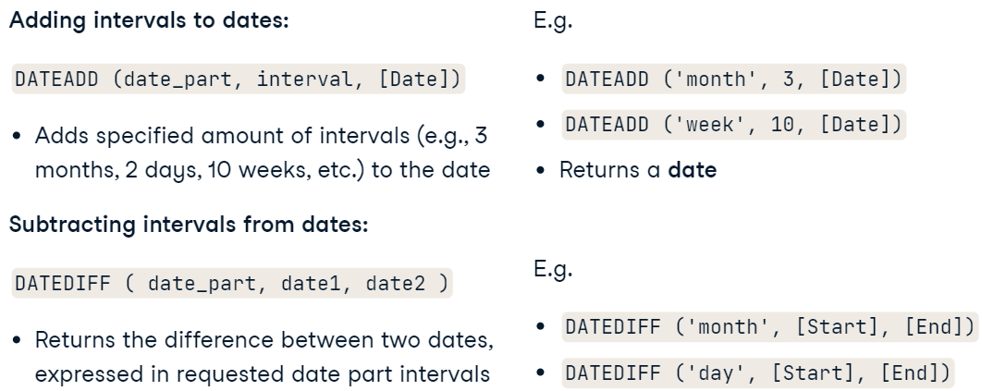

* Hash in calucations:

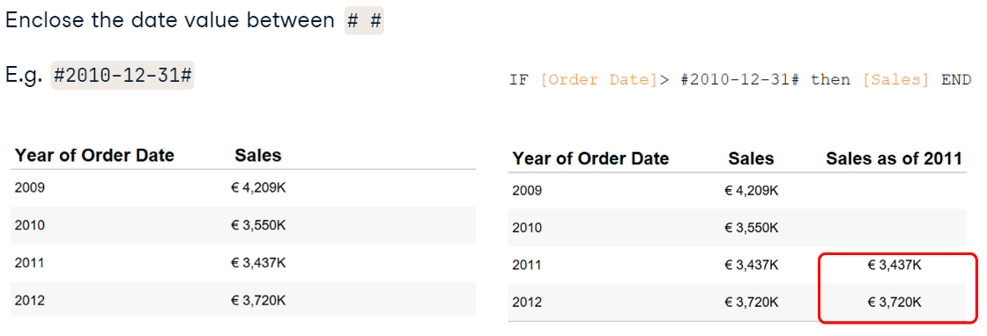

### Time series analysis

#### Seasonality

* What is it?

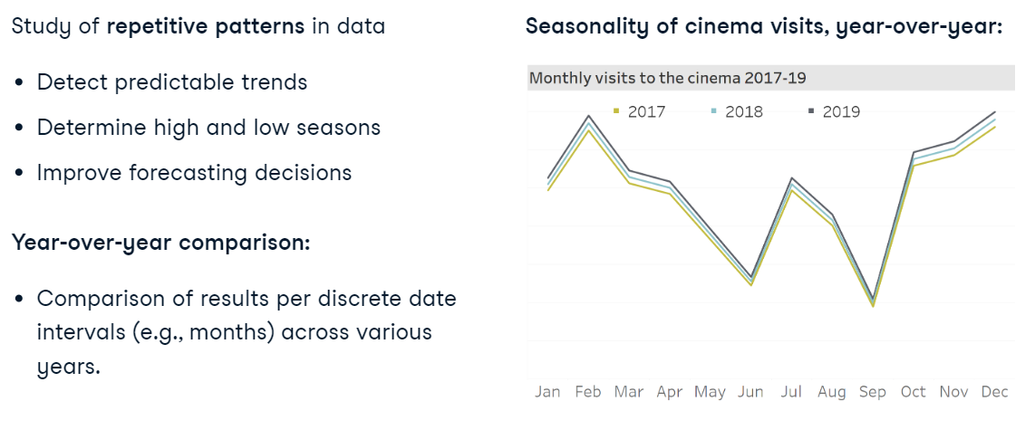

#### Year-to-date and custom fiscal years

* What is it?

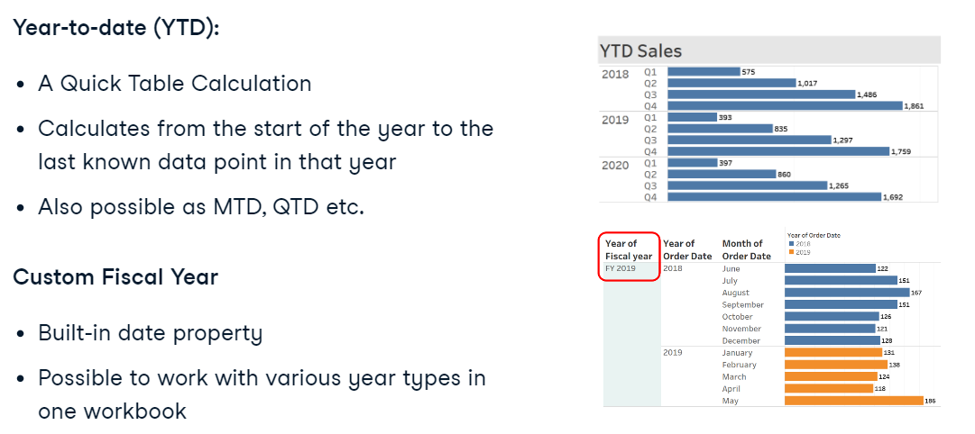

#### Calculating growth

* What is it? (previous or first values)

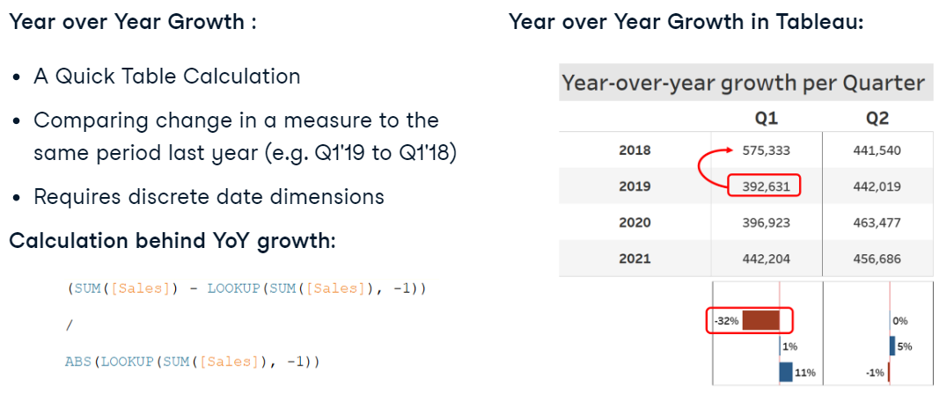

#### Compound Annual Growth Rate - CAGR

* What is it? – use CTC (CGR)

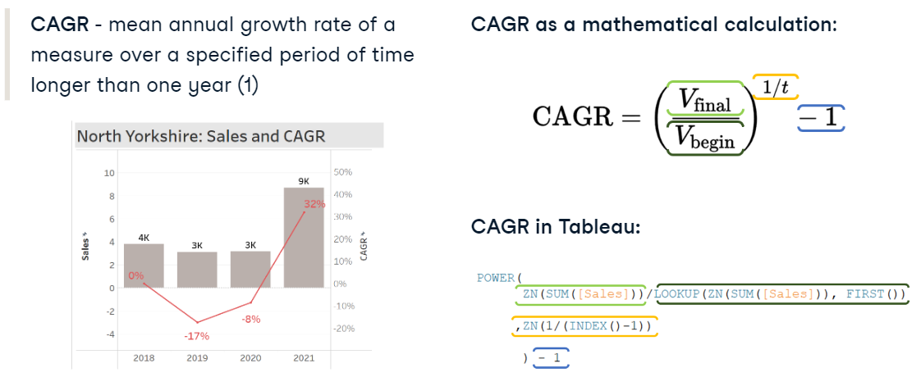

#### Moving calculation

* What is it? – use (moving AVG)

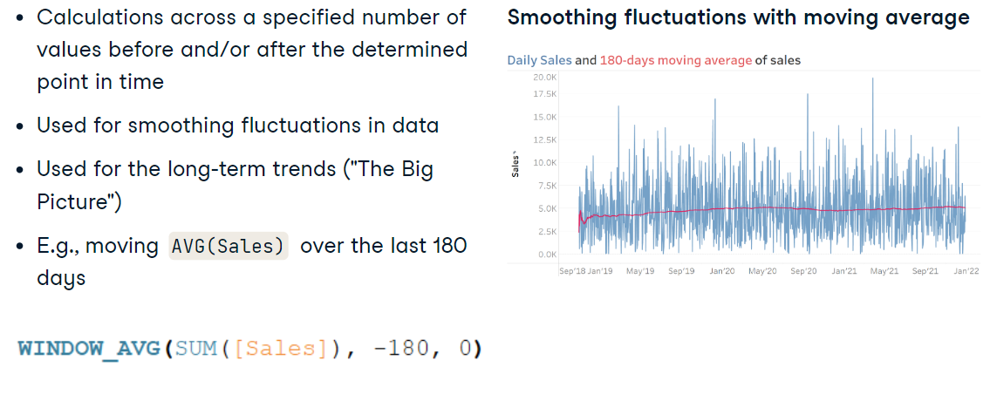

## Statistical Techniques

### Techniques

* Add a header to the column:

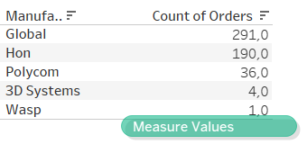

* Disaggregating measures:

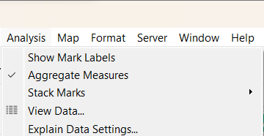

* Sorting by aff_func:

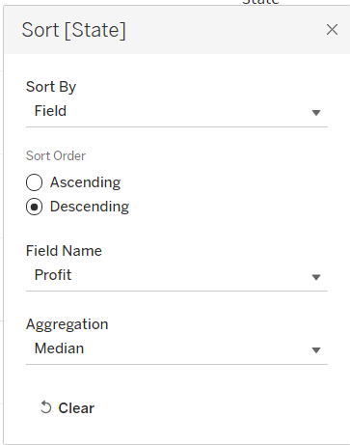

* Show summurt statistics:

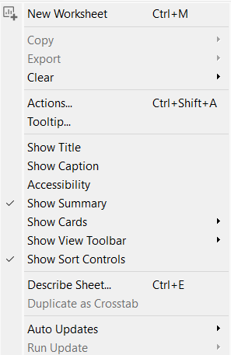

* Adding ST to the viz:

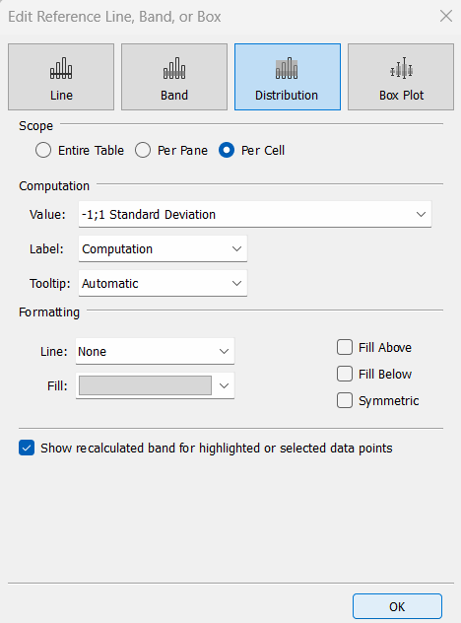

* CI:

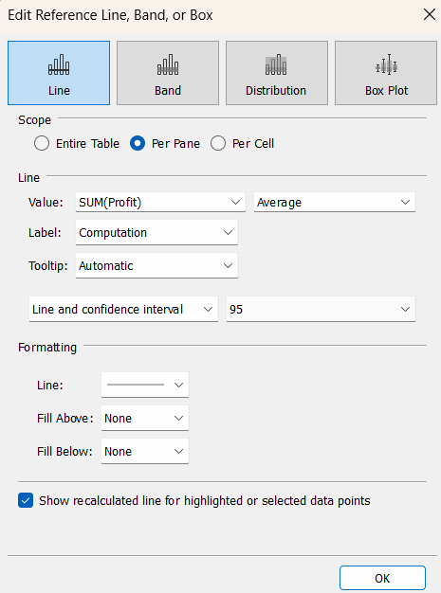

* Band – difference between agg_values!
* Trend lines:

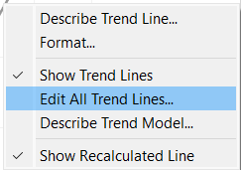

* Forecasting:

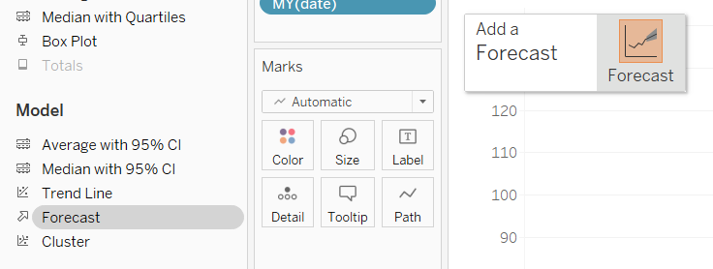

* Describe forecasting:

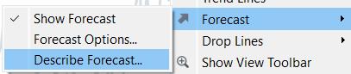

* Transforming forecasting (custom):

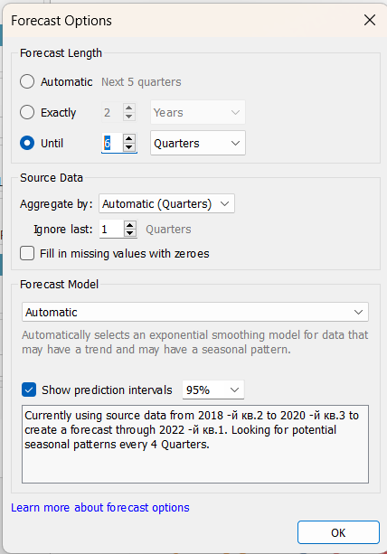

* Adding forecast results to the viz:

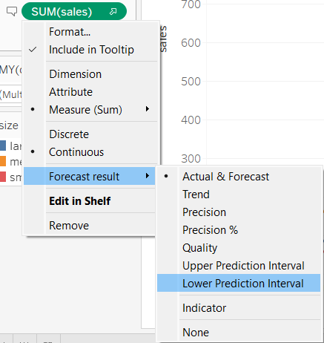

* Clusters:

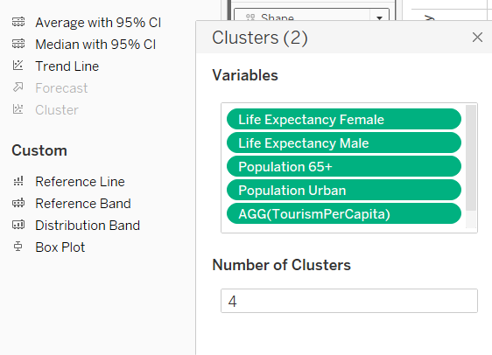

### Distribution

* What is it?



* Skewness:

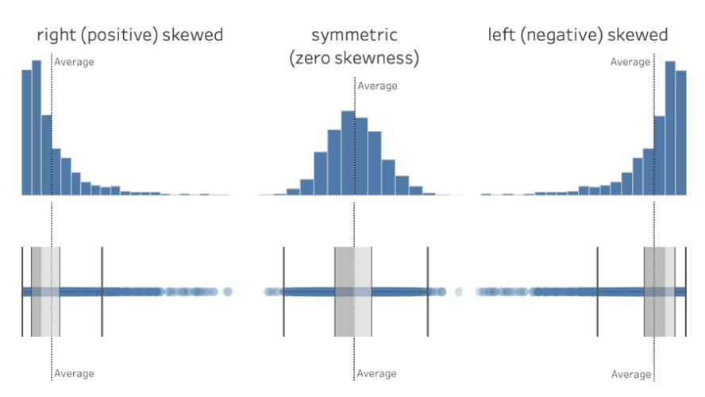

* Kurtosis – how far distibuted from the mean value:

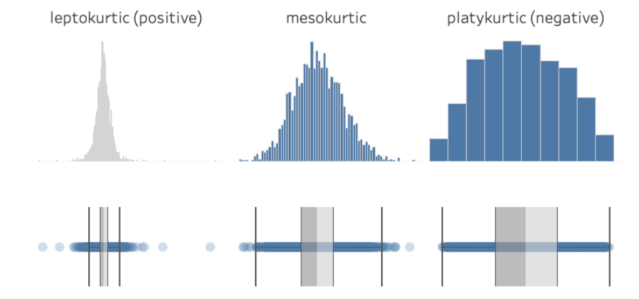

* + Leptokurtic – a lot of extreme values;
  + Platykurtic – a few extreme values.

### Descriptive Statistics

* Types:

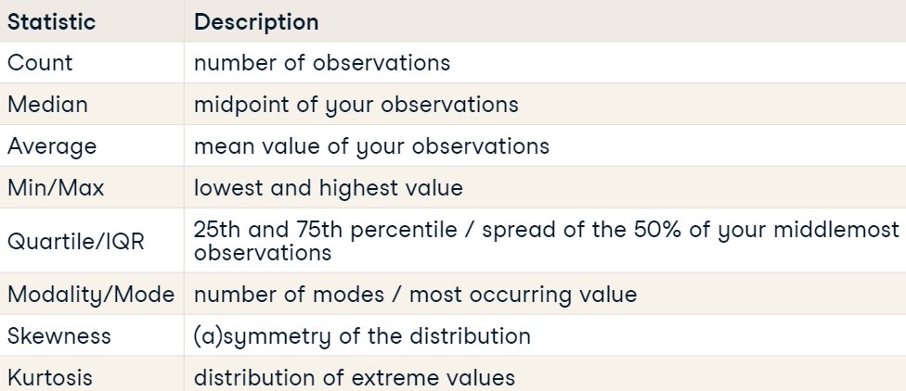

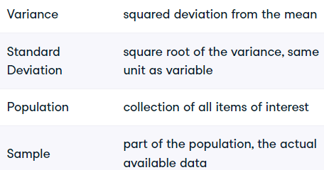

* Sample variance:

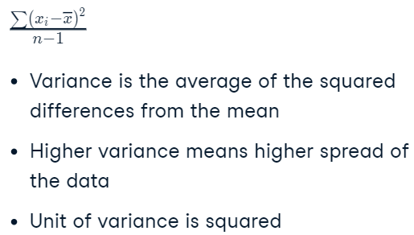

* Sample SD:

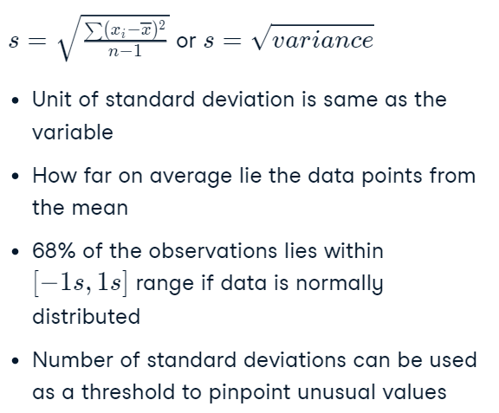

* Sample vs descriptive:

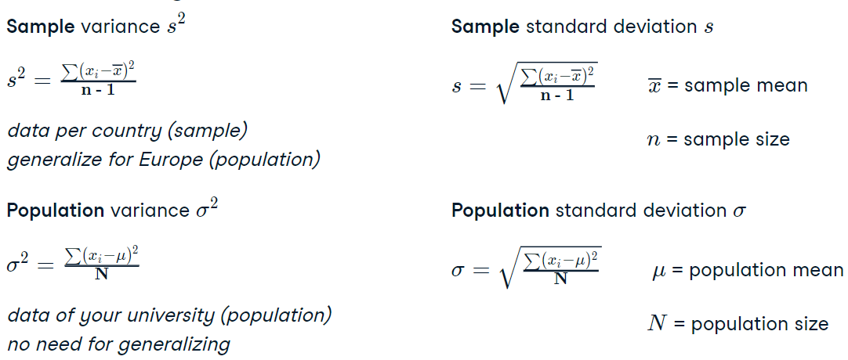

### Standard error and confidence intervals

* Standard Error:

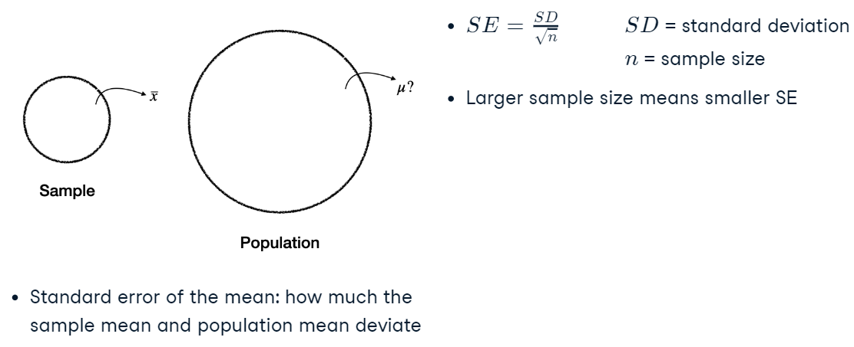

* CI:

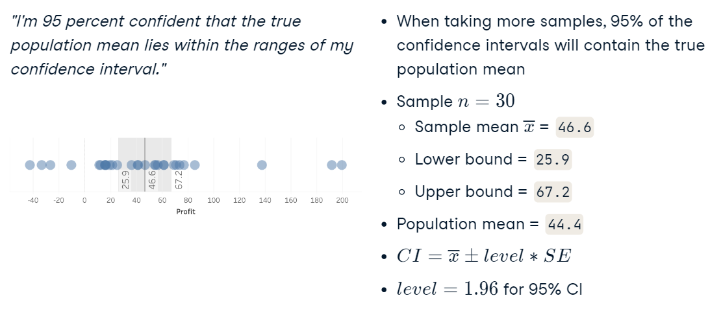

### Correlation

* Types:

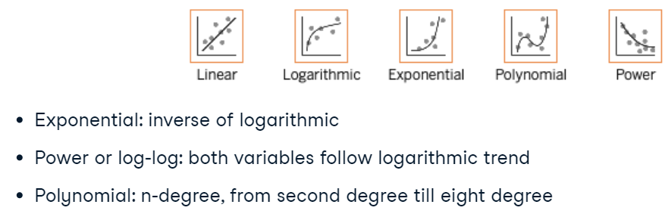

* How the linear model works:

For every meter of higher distance, species richness is expected to increase by 0.0038. The intercept is 13.4, which we can also see on the plot where the trend line crosses the y-axis.

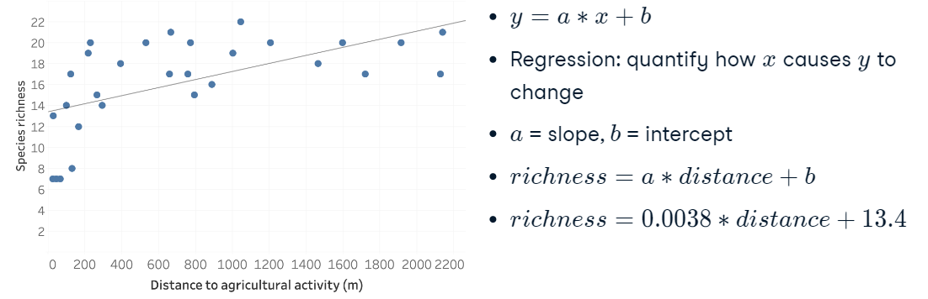

* Residual standart error – avg dist between trend and points (CI):

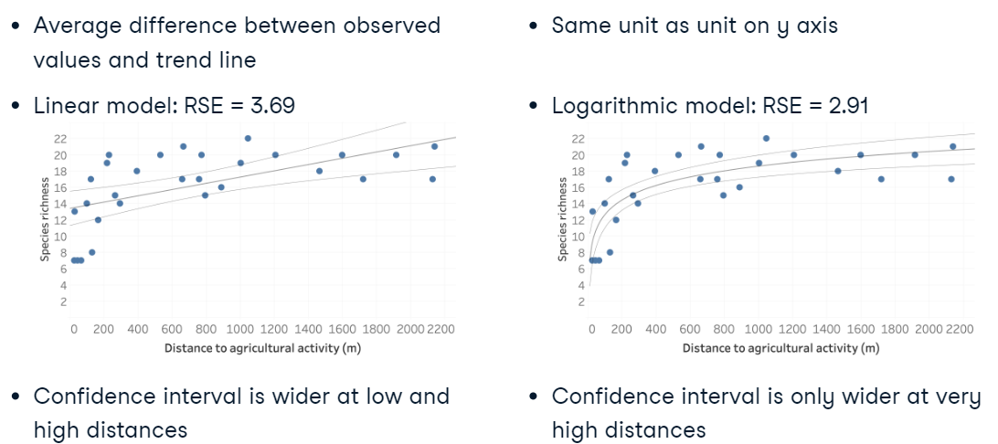

* P-value (chance thst the model doesn’t have the relationship between 2 vars):

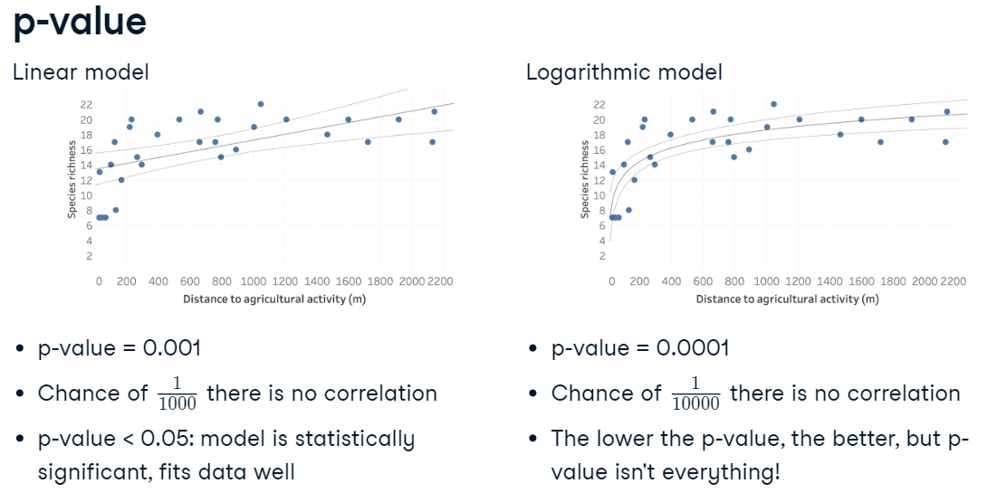

* Model have to fit these conditions:

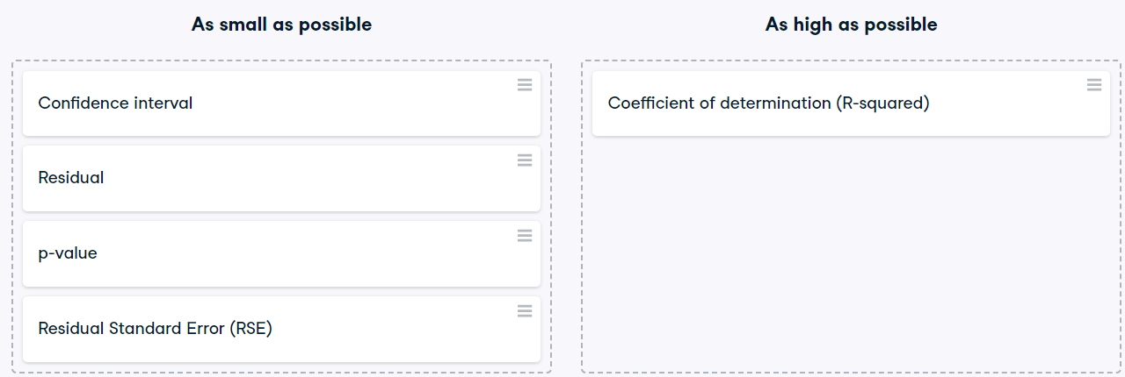

### Forecasting

#### Mean absolute scaled error (MASE)

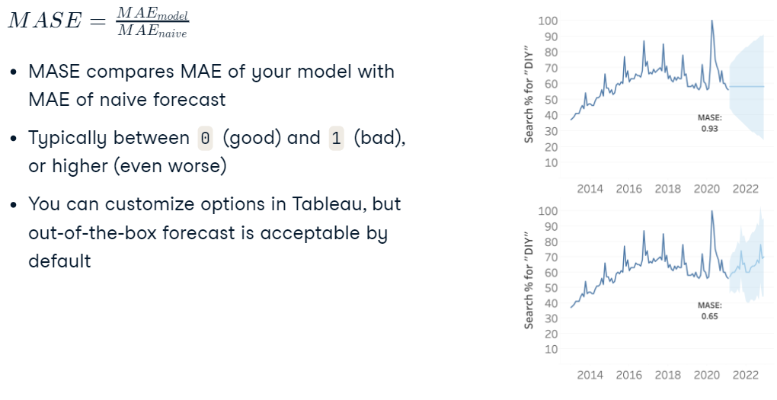

### Clustering

* Process:

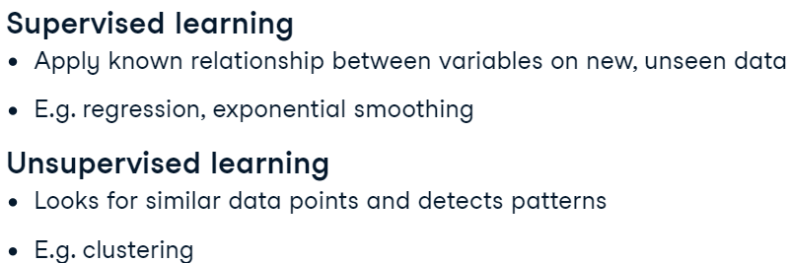

* Assessing the clustering model:

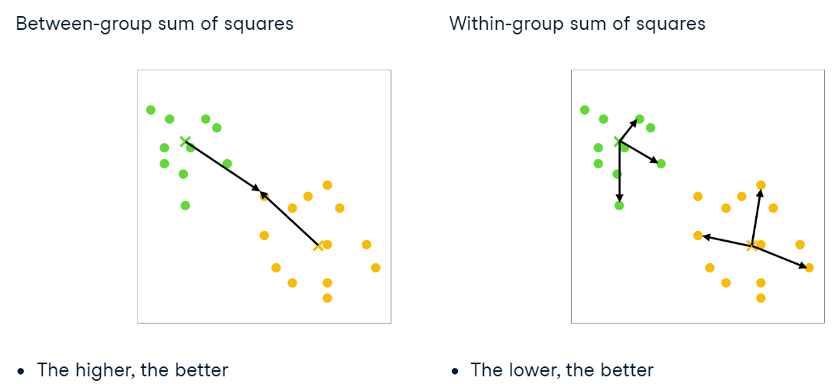

## Analyzing ecommerce data

* E-commerce operations:

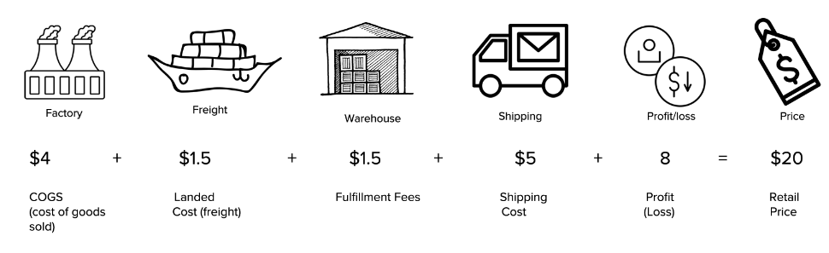

* Increase sales:

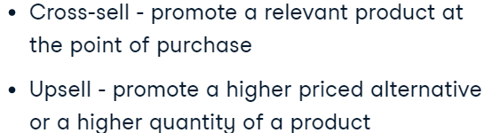

* Shipping expense reduction strategies:

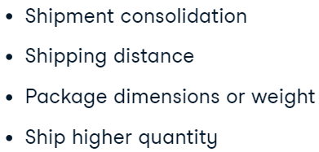

* Market basket analysis:

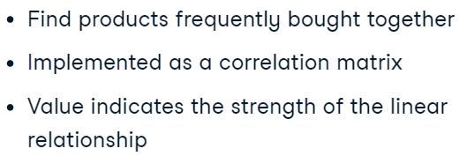

## Storytelling

* How to do this:

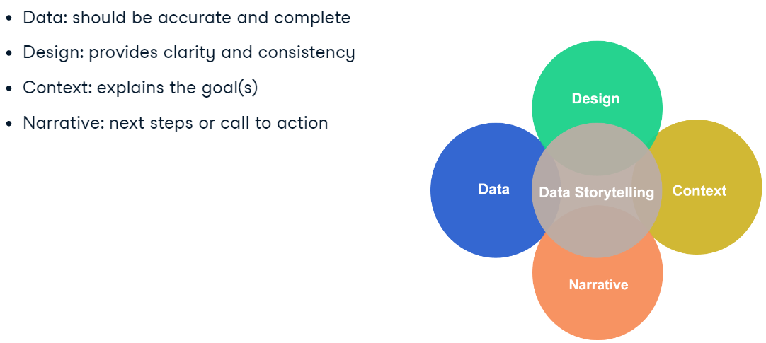

* Interpreting:

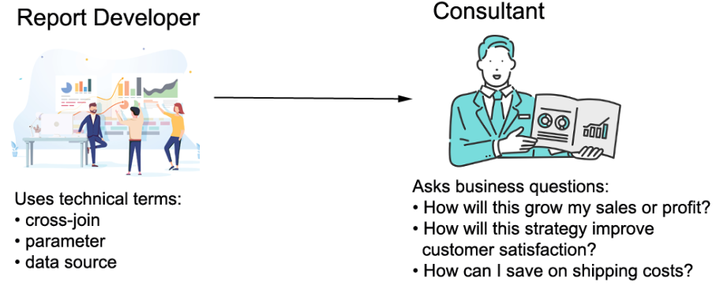

## Marketing Analytics in Tableau

### Web Traffic, Journeys, and Attribution

#### Marketing analytics in Tableau

* What is it and why we need it:

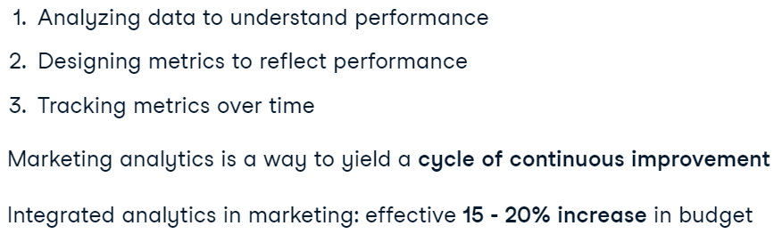

* How does it work:

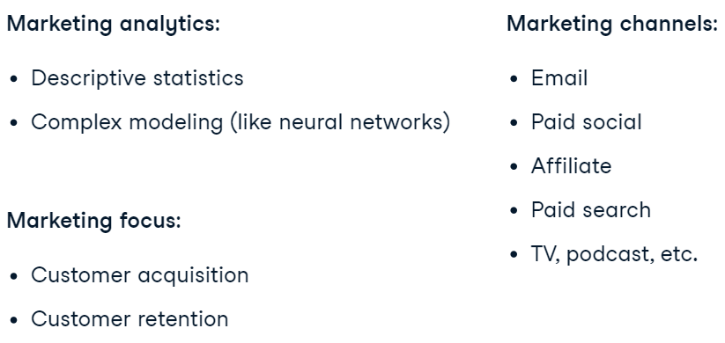

#### Touches, journeys, and attribution

* Marketing attribution:

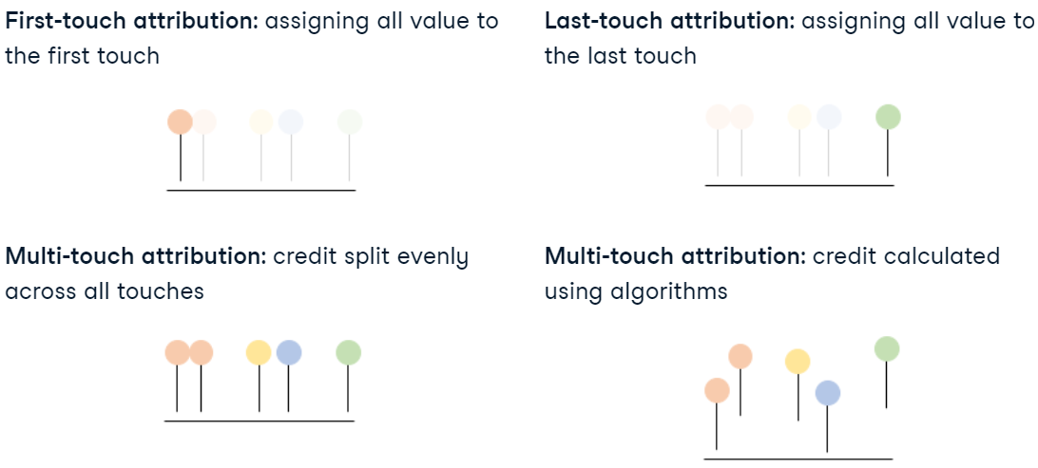

* **Attribution Models**: Attribution is assigning value to each touch point in a journey. Common models include:
  + **First Touch Attribution**: All value is assigned to the first touch.
  + **Last Touch Attribution**: All value is assigned to the last touch.
  + **Multi-Touch Attribution**: Value is split among touches, either equally or based on specific rules or algorithms.
* LookUp (similar to Lead, Lag):

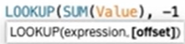

* Works as Partition By in Tableau:

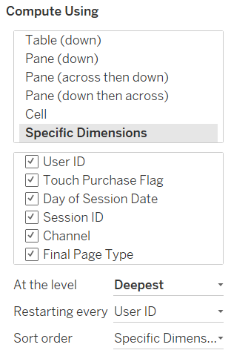

### Email and Paid Social Marketing

#### Marketing funnels

* Funnel:

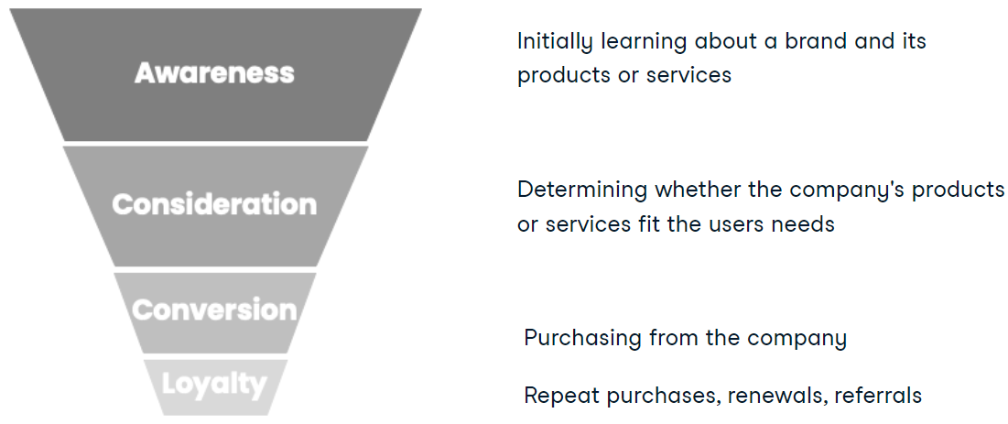

* Funnels and channels:

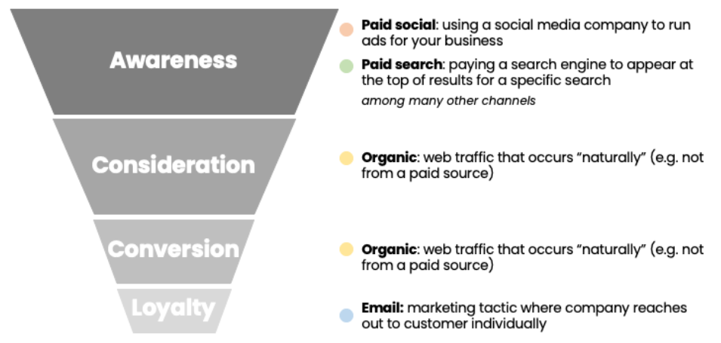

* Call to action by email:

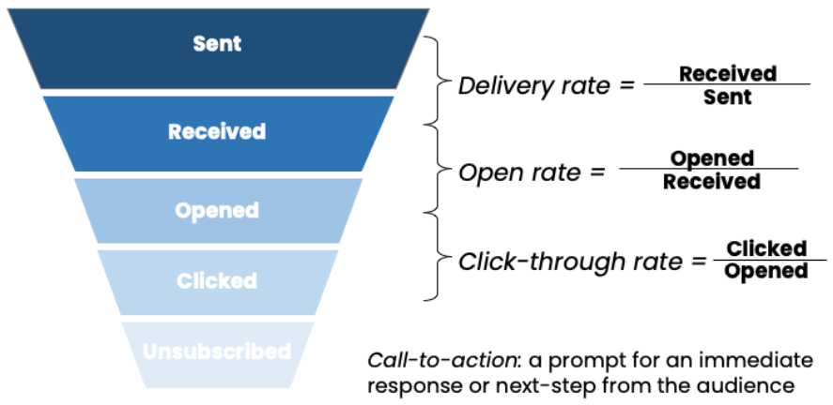

* IF YOU DON’T DO THE AGG IN THE CALCULATION – TABLEAU WILL DO AGG ON THE DEFAULT DATA GRAN, WITHOUT CONSIDERING TABLE VALUES AND WHERE THEY ARE.

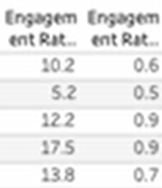

#### Paid social and A/B testing

* Paid social two ways of paying:

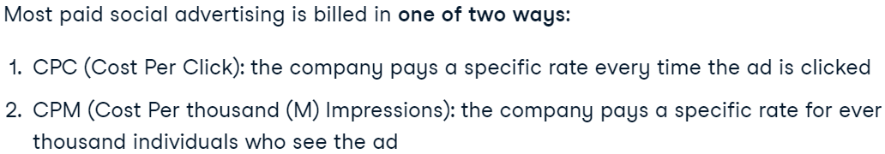

* How to perfom A/B:

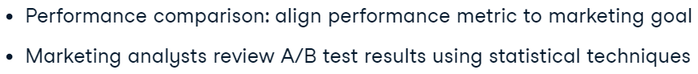

* All ad components of A/B test:

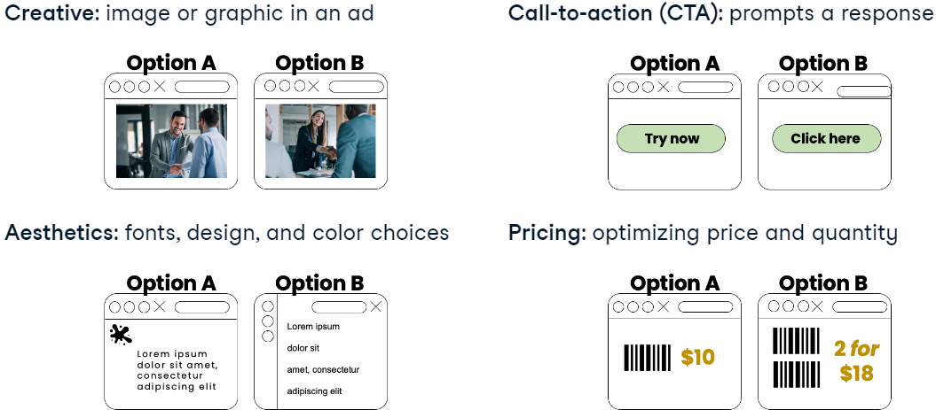

* Components: can test creatives, call-to-actions, fonts, logos, pricing, target audiences, and bidding strategies.
* Click Back Rate:

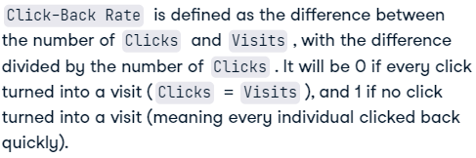

### Paid Search and Organic

#### Paid search

* What is it:

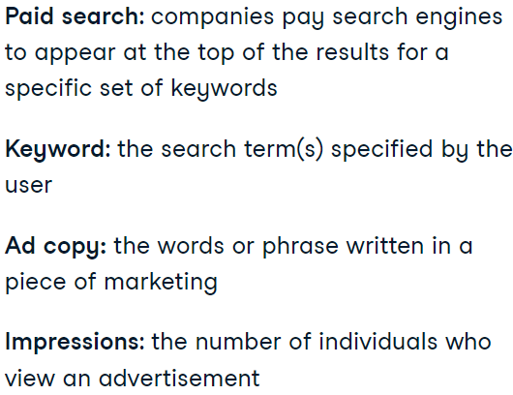

* Branded and unbranded search:

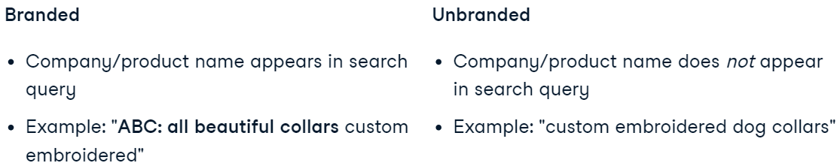

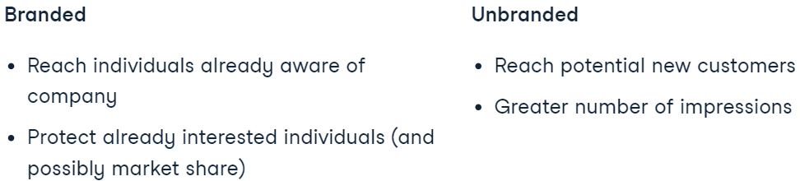

* Exact and phrase/broad match (match types):

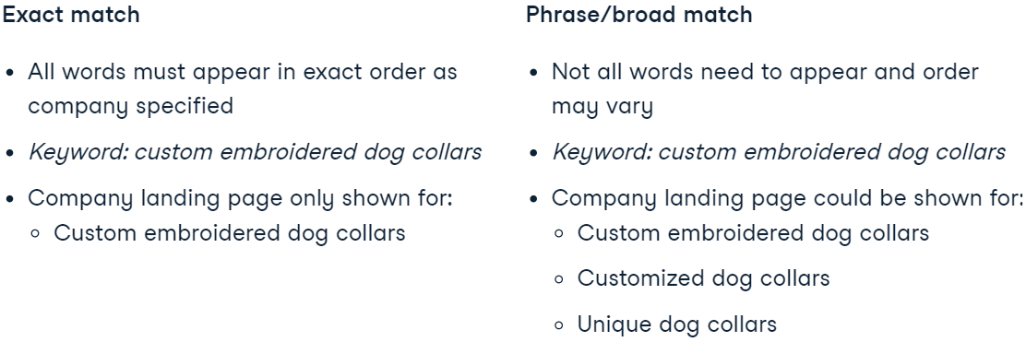

* Ad group:

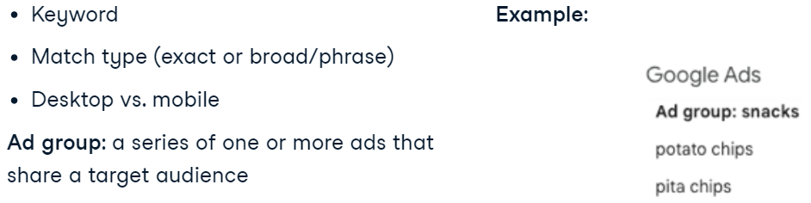

* Impression Share:

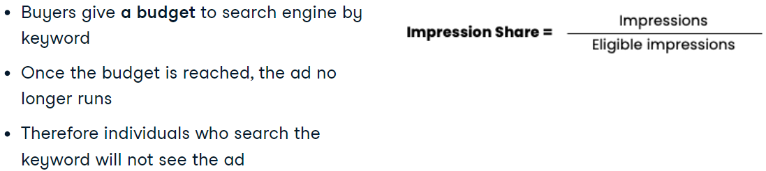

#### What is organic traffic

* What is it:

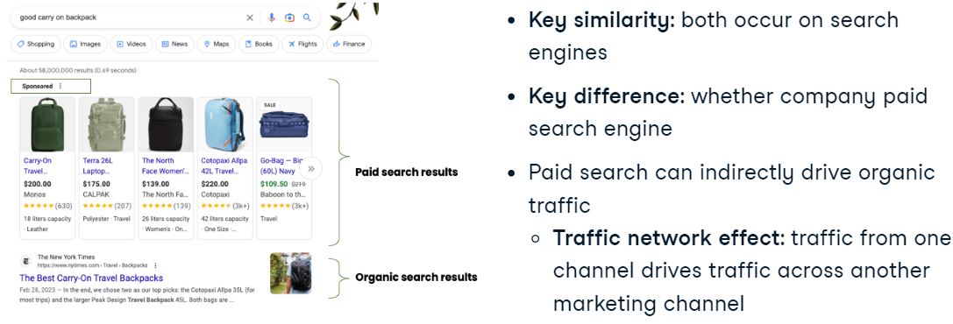

* Pros and cons:

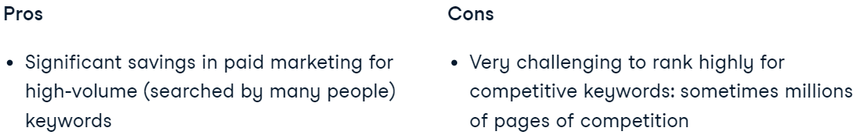

* Search engine optimization:

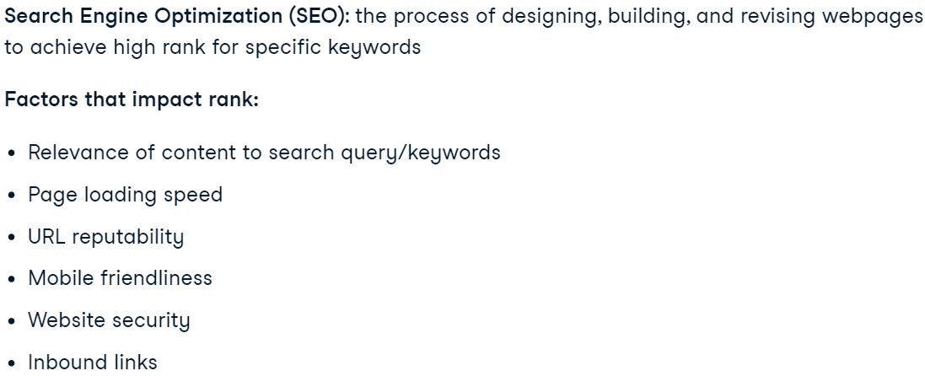

* Organic and digital strategy:

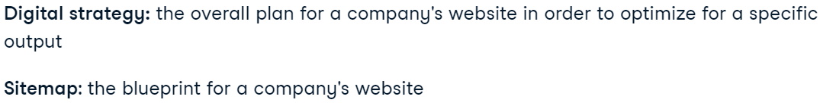

* + How the page looks like:

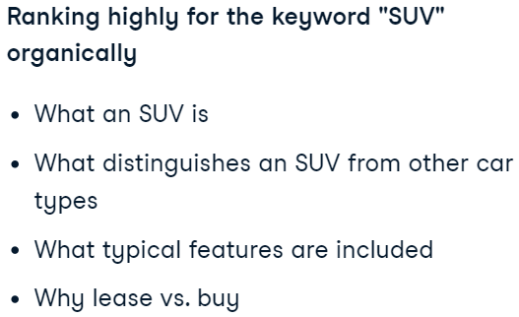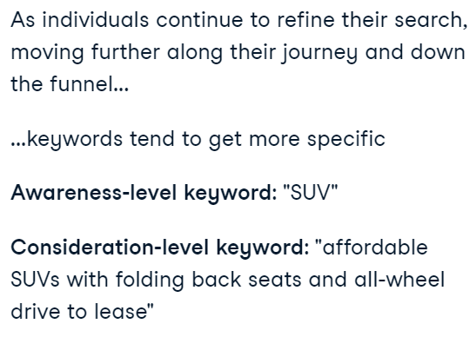

* Why we need optimize each page at the different stages of the funnel:

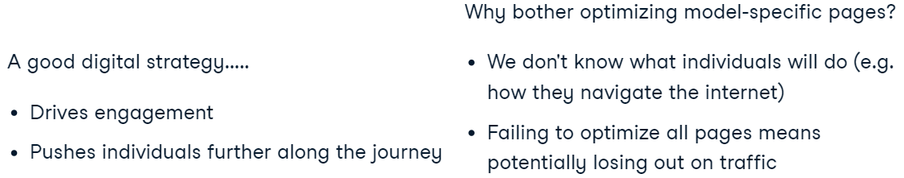

### LTV/CAC

#### Introduction to LTV

* Formulas:

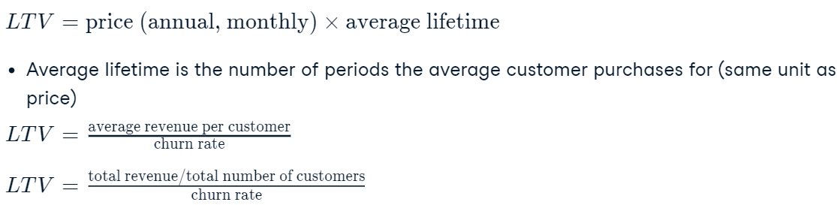

* Churn:

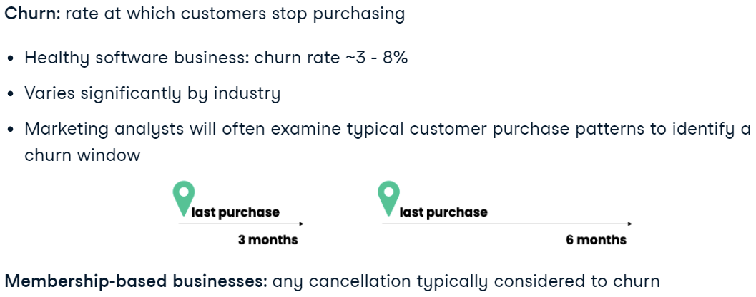

* Cohors:



* LTV / CAC:

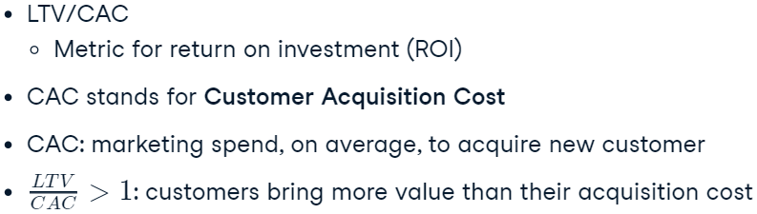

#### Introduction to CAC

* What is it:

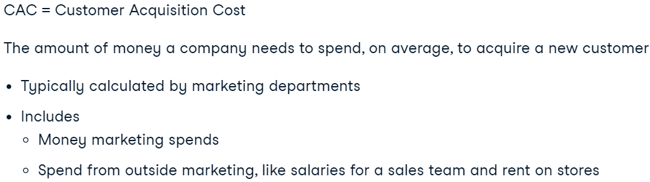

* Formula:



* CAC by industry:

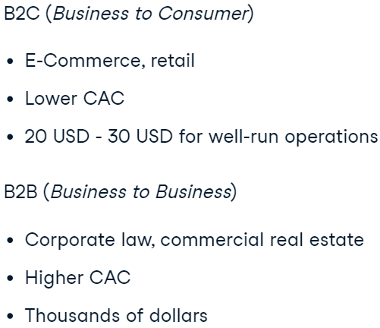

* Marketing spend by industry:

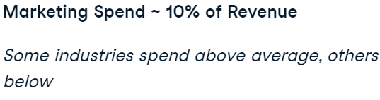

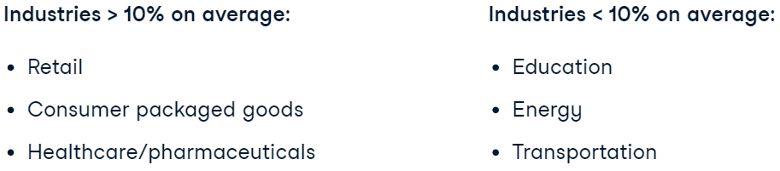

* What is not included:

